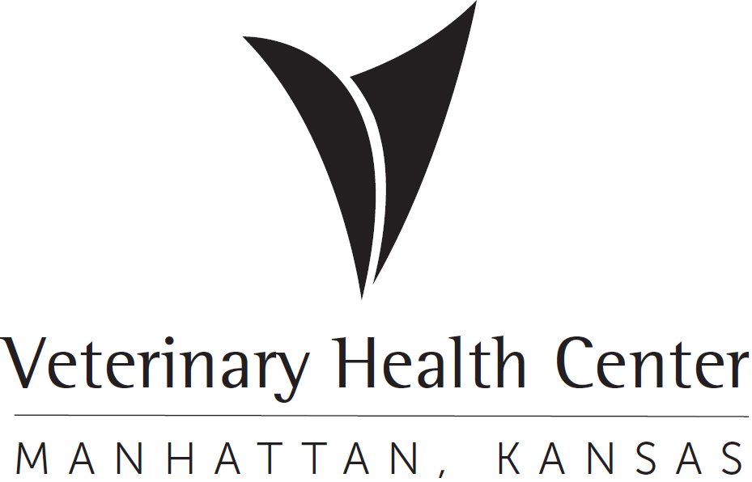 | OFFICIAL PROTOCOL

Primate (Non-Human) Occupational Safety

Purpose: To provide direction to all persons having direct and indirect contact with nonhuman primates (NHP) and/or their bodily fluids or wastes and to inform them of the risks involved.

Due to human health and safety risks associated with providing veterinary care for non-human primates, particularly the Old-world species, it is the policy of the VHC Zoological Medicine Service to highly discourage seeing non-human primate patients. Under no circumstances will we see Macaques (Any Macaca genus) or any primate imported from outside of the United States. If a non-human primate patient is scheduled for evaluation of medical condition or is presented for emergency care, the following guidelines will be strictly adhered to:

- Students are prohibited from working with non-human primate patients without direct clinician supervision AND appropriate PPE (Personal Protective Equipment) must always be worn.
- A member of the Zoological Medicine Service will call the primate owner the morning of their scheduled appointment. The owner will be informed that they will need to bring the animal in a secure carrier and that there will be a primate handling fee associated with the visit. An exam room will need to reserved first thing in the morning on the day of the scheduled exam by placing a sign on the door with its intended use and times. This room will be reserved for the rest of the day, or until properly disinfected.

- All clinicians, staff, and students in proximity to the patient are required to wear the following personal protective equipment. The personal protective equipment is to protect YOU from the primate and to protect the primate from you. Moving through the hospital in your PPE with the primate is required because the risk of disease transmission to another patient is low but risk of disease to a person close to the primate is high.

1. Protective wear (disposable clothing) – this includes a disposable gown. If the gown breaks, it needs to be replaced immediately.
2. KN95 mask

3. Safety goggles or a face shield and goggles.

4. Latex (or other) gloves must be worn when in contact with the patient, patient laundry, or items of clothing. If there is a high concern for infectious disease (example Old World primate), DOUBLE gloving should be done.

- When the non-human primate patient is being transported to the VHC and is in the parking lot (privately owned, zoo primate other than Sunset Zoo), the client and the primate should remain outside the VHC contained in the owner’s car or a carrier until the Zoological Medicine Service clinician is present and prepared to proceed with the case. Someone from the service will then retrieve the owner and animal from their vehicle and guide them directly into the reserved exam room.

A desk staff member can check the animal into Instinct over the phone and an exotics service member can have the client sign the consent form in the exam room.

- Personnel involvement will be limited to the minimum number of people needed to care for the case to reduce human exposure to the non-human primate.

F. At the end of the appointment the owner should be directed back to their vehicle. Payment for services can be made over the phone.

G. After the exam room is cleared the desk staff will be informed so that they can have the room terminated. The Zoological medicine service will clean all ward rooms and materials exposed to the primate patient. All appropriate PPE must be worn, and all surfaces need to be cleaned with the terminal rate of disinfectant. The disinfectant should be left on all surfaces for 10 minutes of contact time and then wiped dry.

H. All materials, supplies and instruments used in treating primates must be placed in biohazard bags and taken to Central Prep. Items must be sorted into appropriate biohazard bags (biohazardous materials versus biomedical waste). ALL contaminated biohazardous materials must be cleaned prior to placing in a biohazard bag, secured with an appropriate twist tie, labeled with “Non-Human Primate”. Please dispose of all biohazard trash into the large red bin marked “VHC” in the metal corral outside behind the diagnostic lab. Do NOT mix bedding, cloth, instruments, tubing, trash, etc.
Do Not fill biohazard bags over 2/3rd full.

- Equipment must be cleaned prior to returning it to Central Preparation. Dirt, blood, hair, or other debris must be removed.
- Instruments must be free of tissue, blood, and debris. If not clean, they will be returned to the Exotics service for cleaning.
- Items must be separated and placed in separate biohazard bags
  - Metals
  - Plastics
  - Linens
- Steam Sterilization:
a. Stainless steel instruments
b. Surgical linens, (pan covers, blue towels, pack wraps)
c. Linens must be blood, tissue, and urine free.
d. Do not place wet linens in the biohazard bags. Hang to dry in a designated area before bagging.
- Low temperature sterilization:
- Clippers and clipper blades
- ET tubes
- Non-rebreathing tubing, breathing bags and face masks will be soaked in a chlorhexidine solution (1 ounce (2 tablespoons) of Chlorhexidine Solution per gallon of clean water) or dilute bleach solution (1:10 ratio).
Contact Time for chlorhexidine and for dilute bleach - Let stand in solution for 2 minutes, rinse thoroughly, then wipe and hang to air dry in designated area.
- Patient towels, bulb syringes and suction tubes should be thrown away in biohazard trash.
- Heavily soiled or known contagious materials must be thrown away in biohazard trash.

Biomedical Samples
NHP (nonhuman primates) biological samples (i.e., urine, blood, semen, feces) should be placed in containers within clearly labeled (i.e., species and identification) leak-proof secondary containers (e.g., sealed plastic container or bag) for transport to the clinical pathology laboratory. This is necessary to prevent contamination of surfaces during transport and handling. Persons preparing these samples should wear gloves to prevent contaminating the outside of the container or should wipe the outside of the container with appropriate disinfectant. Specimens being sent to outside laboratories should have additional labeling to identify them as “nonhuman primate” samples.

Biomedical Waste

- Sharp disposable materials (e.g., scalpel blades, needles) must be disposed of in a red plastic sharps container. When all the sharps have been collected, close the lid, and take the container to Mosier B-116 (Ward Services room) and place it on the counter. This container is to be used once and then disposed of.
  - Do not attempt to recap any needles, rather place them directly in the sharps container. Recapping needles presents a significant human health risk due to potential for needle stick injury and transmission of infectious disease.
  - Extra caution should be taken when dealing with any sharps in surgery for the same reason.

- Solid Biohazardous Waste

- Personal Protection Equipment (PPE) such as protective wear (disposable gowns/clothing), latex (or other) gloves, and face mask (or safety goggles) must be worn by staff when in contact with the patient. Patient laundry or clothing items in direct contact with the nonhuman primate must be placed in a biohazard bag for disposal.

- Trash (such as paper towels, used gauzes, cloth like materials, plastics) are to be placed in a separate biohazard bag from the surgical equipment and sharps for disposal.

- Linens and bedding will be placed in a separate biohazard bag from trash and PPE.

- Biomedical waste will be disposed of in Mosier J-129 in an available rigid, leak-proof container. Do not place bags on the floor.

Biohazardous Bags

- All items coming into Central Prep contained within biohazard bags must be bagged and closed at the point of use. Do not transport open bags through the hospital. Bags must not be filled more than 2/3 full.

- Bags must be zip-tied with biohazard ties at the point of use. Bags that are folded over and taped will not be accepted by Central Preparation personnel.

- Individuals who deliver biohazard bags containing materials from non-human primary patients to Central Prep must verbally communicate the contaminant delivery to the Central Prep staff.

Standard Operating Procedures:

- Personal Hygiene-Any person that will be entering or working in an area of a NHP should adhere to good general hygiene practices
  - Eating, drinking, applying cosmetics, or handling contact lenses should NOT be permitted in an NHP area. Any food intended for human consumption should not be kept or opened near an NHP.
  - Handwashing should be performed before handling animal food items, after removing gloves, before leaving a primate area, and before eating, drinking, applying cosmetics, handling contact lenses, or smoking after working in a primate area.
  - Masking should be done prior to handling food to be offered to the animal.
  - Disposable gloves should be changed often and when going from one activity to another (i.e., from cleaning to feeding), and when they become soiled or develop tears or holes.
  - Work clothing should be changed when visibly soiled or contaminated.
  - People should shower when contamination of skin or hair has occurred.
  - Nets, protective leather gloves, and other equipment should be cleaned and disinfected following each use. Since complete disinfection may be difficult, leather gloves should be dedicated for nonhuman primate use.

- If scratched, bitten, needle skin prick, or feces and/or urine is exposed to the nose, mouth, or eyes:

  - For skin exposure: Immediately begin by flushing and/or scrubbing the affected area with chlorhexidine or betadine scrub and running tap water. Continue this process for 15 minutes. Do not use chlorhexidine or betadine scrub in the eyes! For a briskly bleeding or other serious wound, go directly to Ascension Via Christi Hospital.

  - For eye or mucous membrane exposure: Immediately irrigate with sterile saline or water for 15 minutes. Use an eye wash station when available.

  - Apply a temporary bandage from the First Aid Kit.

  - Immediately proceed to Ascension Via Christi Hospital for medical evaluation and wound cultures if indicated.

  - Report the accident to your supervisor immediately. Do not let this step delay the seeking of medical care. If you cannot communicate with your direct supervisor, proceed to an emergency care facility as the first step.
    - Report the ID number of the animal to which you were exposed, the location where the exposure took place, and the type of exposure.
    - If you are unable to contact your supervisor before going to the hospital, report the accident to your supervisor as soon as possible after the medical evaluation.

Diseases of Concern:

- Tuberculosis: Tuberculosis is a serious debilitating disease of primates that is caused by Mycobacterium tuberculosis. Old World primates are most susceptible, but tuberculosis also occurs in New World monkeys and great apes. Inhalation and ingestion are the most common routes of transmission. Clinical signs in primates include debilitation, coughing, chronic diarrhea and draining skin lesions.
- Cercopithecine Herpes Virus I (B Virus): B virus can cause fatal encephalitis in humans. Macaque monkeys and other Old-World primates are the natural hosts for this virus, and they usually have no clinical symptoms associated with the infection. When they are shedding the virus, they may have a mucocutaneous ulcer (cold sore) on the lips. The virus is transmitted via bites and scratches, or by mucous membrane contact with infected secretions (including blood, saliva, or urine).
- Simian Immunodeficiency Virus (SIV): This virus, present in some species of Old-World monkeys, causes a clinical disease in monkeys that is like human AIDS. There is evidence of seroconversion to SIV in humans and the long-term effects are unknown. Avoidance of secretions is strongly recommended.

