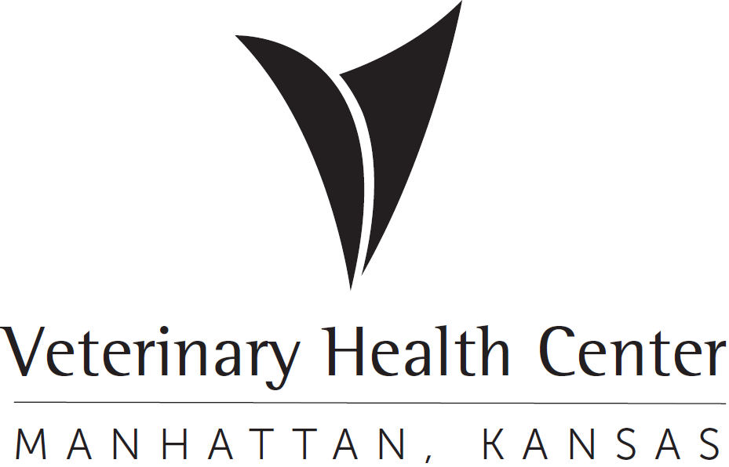 | OFFICIAL PROTOCOL

KSU DAIRY BIOSECURITY (SALMONELLA)

When the KSU Dairy has Salmonella or Salmonella suspect cattle either at the dairy or in the VHC, the following protocol applies:

- Equine Section

A. Equine faculty, house officers, veterinary nurses and senior students will not access the Large Animal (LA) barn. Please access LA Isolation via 1-70 or outside entrances.

- Agricultural Practices Section

A. Livestock Services faculty, house officers, veterinary technicians and senior students will not access the Equine barn.

B. Livestock Services faculty, house officers, veterinary technicians and senior students must adhere to established decontamination procedures when accessing the equine hospital. Clinicians and students should not access the equine hospital on the day they have been to the KSU Dairy or have treated a patient from the KSU Dairy.

C. Livestock Services faculty, house officers, veterinary technicians and senior students who have been to the KSU Dairy or have treated a cow from the KSU Dairy will not access common areas; i.e. the equine computer room, the equine telephone room, LA desk, LA waiting room, copy machine room and the equine client consultation room until after they have followed decontamination procedures. See paragraph D. below.

D. Persons who go to the KSU Dairy must wear rubber boots. Organic debris must be cleaned from boots prior to leaving the KSU Dairy. Upon returning to the VHC or from treating an animal in the VHC , rubber boots should be cleaned, completely covered with disinfectant and allowed to air dry (do not rinse disinfectant). Foot baths must be prepared fresh after every visit to the KSU Dairy or after treatment of a dairy suspect animal in the VHC.

E. Livestock Services calls to the Dairy will be limited to afternoon visits and Livestock Services faculty, house officers, veterinary technicians and senior students should return to the VHC by 4:00 pm so the vehicle(s) and garage can be disinfected. Emergency calls are exceptions to this protocol

F. It is preferred that suspect cows remain at the KSU Dairy. If they are admitted to the VHC, they will be placed in LA Isolation. Non-suspect KSU Dairy cows will be hospitalized on Tier 3.

