 | OFFICIAL PROTOCOL

Human Post-Bite Protocol

Purpose: To provide direction of what to do when a VHC member is bitten by a patient at the Veterinary Health Center.

Important Initial Steps

- If deemed a life-threatening situation, call 911 for emergency response of medical team.
- Wash bite wound immediately and thoroughly with soap and water. Flushing with povidone iodine is also recommended if available.
- Employees, including student workers who were being paid by the VHC at the time the bite occurred, should follow the process for reporting an employee work-related accident by completion of an incident report. (see attachment)
- CVM students on clinical rotation (not employed by the VHC) need to notify Clinical Science Office that the accident occurred. Students need to complete the student accident report. Students should seek medical care as appropriate and follow their personal medical insurance process for medical care costs.
- A reportable bite is defined as one where the animals’ teeth pierced or broke through the skin. If the skin was not pierced the bite report does not have to be completed.
- When a bite occurs, an email should be sent to Drs. Davis and Duvendack with “Bite occurred in VHC” listed in the subject line.
- Individuals who were bitten should consider seeking medical attention ASAP, even if low risk of rabies transmission, as a tetanus booster and/or antibiotics are commonly indicated at the time of animal bite wounds.
Responsibilities of Senior Clinician or Veterinarian following bite
- The primary clinician on service for the VHC patient needs to call Riley County Police Dept. (RCPD) dispatch (785-537-2112) to have an animal control officer (ACO) determine the most appropriate course of action, which may involve collecting information for a formal animal bite report.
    - The clinician needs to ask to speak with a dispatcher so they can contact the ACO and advise them they are needed at the VHC because of an animal (provide species) bite wound.
    - Please have the contact information for the person involved and the patient owner when making the call. Both persons bitten and the owner of the animal will be required to answer questions for the ACO.
    - If the animal is confined when called in, the ACO will not respond after hours for bite or rabies exposure. Current hours of operation are Monday – Friday 7:30A – 6P.
    - If both the person who was bitten and the animal are fully vaccinated for rabies with no suspected symptoms:
      - The dispatcher should be told this is a low-risk bite so the ACO can prioritize their calls.
      - If the rabies vaccinations can be confirmed for both the person and animal, the animal can be released from the VHC.
      - The ACO will follow up with all parties to complete the rabies exposure and will contact the patient owner to coordinate home observation.
      - If the owner lives outside of Riley County, this will be coordinated through the respective agency for that jurisdiction.
    - In a situation where the animal does not have a current rabies vaccination that can be confirmed:
      - The patient may not be released from the VHC until the ACO has provided the information to the senior clinicians and the report has been completed.
      - The ACO will determine necessary steps for 10-day observation period. It is important to request the VHC be notified of arrangements for the observation period. This information will include whether the animal can be released from the VHC, the animal should not be discharged from the VHC until the ACO has provided this information to the senior clinician.
      - If the animal is not owned, the ACO will direct appropriate animal care. This information will include whether the animal should be euthanized and tested for rabies.
- Animals should NOT be vaccinated during the observation period.
- If the animal should become unavailable for observation, it should be treated as a rabid animal and consultation with the KDHE (785.296.1500) is recommended. Note that the likelihood of rabies transmission from an animal current on its rabies vaccine is uncommon.
- Follow the established VHC Rabies protocol if patient is symptomatic. Signs of rabies include fearfulness, aggression, excessive drooling, difficulty swallowing, staggering, paralysis, seizures, uncharacteristically affectionate, self-mutilation, or increased sensitivity to light.
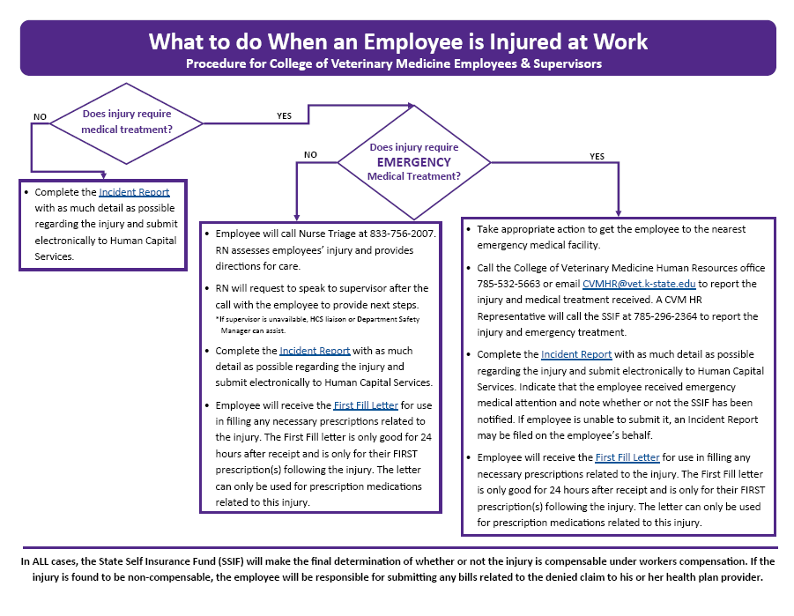
- All warm-blooded animals can be infected with rabies. Birds and reptiles do not transmit rabies.

