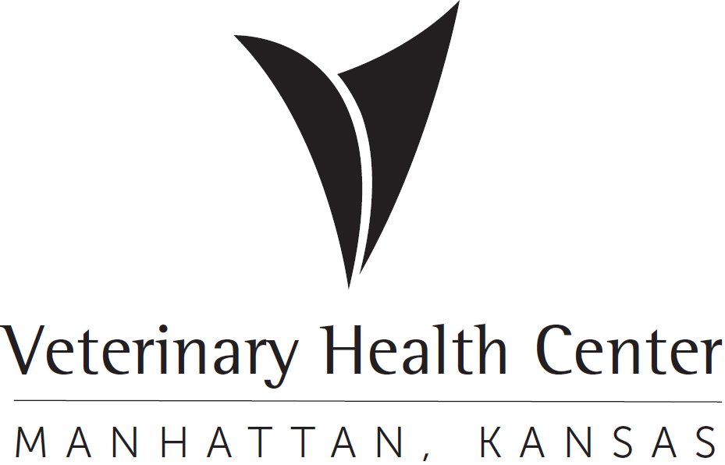 | OFFICIAL PROTOCOL

Non-Exotic Good Samaritan Animals

Purpose: This document is designed to provide guidance on the admissions, clinical management options, transfer, and financial considerations of cats and dogs presented to the VHC by Good Samaritan individuals as “Good Sam.” The Veterinary Health Center will provide care for any sick, injured, or neonatal non-exotic Good Samaritan animal that presents to the hospital. The goal of the VHC is to provide care to alleviate pain and suffering of animals within the Manhattan, KS community until they can be safely transferred to a responsible party.

Definitions
- Non-exotic Good Samaritan Animal (Good Sam) - A sick or injured cat or dog whose owner is either unable to be contacted or not known at the time of presentation.
- Exotic Good Samaritan Animal - exotic or wildlife animal presented to the VHC. See Wildlife Good Samaritan protocol for details.
- Responsible party – The shelter, rescue, or individual that will take temporary ownership and financial responsibility for the animal until a permanent home can be found.
- Basic medical interventions: such as, fluid support, pain medications, antibiotics, heat, nutrition, and any basic life needs up to $200.
- Transfer – The point in time when the financial responsibility and potentially the physical responsibility transfer to the responsible party from the VHC
- Non-critical – Patient afflicted with disease or injury that has minimal effect on quality of life; and under normal circumstances could be treated with outpatient management.
- Owner – The person claiming ownership of the GSA. The person must give a reasonable identification (color, sex, or other identifiable markings, etc.) of the animal in question.

Responsibilities
- VHC faculty/staff/students: intake Good Sam patient that comes to the VHC from public to provide basic triage and stabilization and husbandry until transfer to a responsible party can be achieved.
- T. Russell Reitz Animal Shelter – Quickly and efficiently take over physical and/or financial responsibility of GSA patients within operating jurisdiction once made aware of admission.
- Riley County Humane Society (RCHS)– Quickly and efficiently take over physical and/or financial responsibility of GSA patients that will be admitted into the RCHS rescue.

Client Services
**Note: the following procedures are listed in sequential order, but many of the tasks may be performed simultaneously**
- Member of public presents dog or cat as a Good Samaritan animal (GSA)
  - Animals presenting sick/injured or deceased upon arrival (DOA), proceed with step 2.
  - Cats presenting healthy must be triaged by the RVT or clinician prior to the Good Samaritan leaving the animal at the VHC to see if it can be admitted or not. Healthy cats will only be kept if the triage determines the cat has a microchip or is declawed. All other healthy cats will be advised by an Animal Control Officer on the community guidelines on how to return the cat. The VHC is not able to accept them.
  - Dogs presenting healthy, the RVT or clinician should triage, scan for microchip (see below for instructions), and provide information on how to report lost pets. If needed, the animal can be safely boarded until the VHC can contact the local officials to determine the most appropriate course of care and action.
- The electronic medical record created by VHC Client Services will include 2 documents: 1. Good Samaritan Client Intake Form and 2. Good Samaritan Physical Exam Form & Release
  - “Good Samaritan Client Intake Form” must include this information:
    - Good Samaritan information: Name, Address, Phone number
    - Where the animal was found (address, cross streets, landmarks) consistent with the county reporting document to support why it was a community nuisance or danger. This is essential information at the time of intake.
    - Date and time animal was found. If the GSA has provided care for the animal for 14 days or more, the animal is no longer considered a stray and should be registered under the client, who will then be the one to assume financial responsibility for care if they still wish to have that done.
    - The Good Samaritan should be asked if anyone has been bitten or scratched. If yes, the injured person’s name and contact information and when it occurred should be collected at the time of presentation.
- Do not post pictures or information of the Good Sam online. This is a violation of CVM policy.
**Additional information about the GSA should not be provided to the Good Samaritan once the GSA is left at the VHC as they are not the legal owner of the animal.
Clinical Management
- The GSA will be seen by the appropriate VHC service/clinician to perform the remaining clinical management process
  - 8:00 am – 4:00 pm Monday through Friday
    - Stable patients, and those sick/injured that are not Code 10’s, received by Pet Health Clinician
    - Code 10s received by Urgent Care
  - Afterhours coverage: Emergency receiving clinician or house officer will transfer the patient to Pet Health at the end of their shift.
- Complete the “Clinical Staff” portion of the “Good Samaritan Client Intake Form” created by VHC Client Services and start the Good Samaritan Physical Exam Form & Release
  - Must include via the “Good Samaritan Client Intake Form”:
    - Describe any form of identification (collar, ID tag, rabies tag, tattoo, etc)
      - If present – notate information provided in the medical record.
      - If absent – write “no identification visible” on form.
    - Result of microchip scan by a veterinary nurse, house officer or a clinician.
      - If positive – write microchip number on form.
        - Search the AAHA microchip registry database. www.aaha.org/your-pet/pet-microchip-lookup/microchip-search/
        - If it is a Home Again microchip, contact them at 1-888-HOMEAGAIN (1-888-466-3242).
      - If negative – write “no microchip found” on form.
    - Description of animal (species, breed, color, age, sex,).
- Search for animal identification by means of rabies tag, ID tag, tattoo, and/or microchip.
  - Utilize universal microchip scanner located at the emergency desk to scan for presence of a microchip. Be slow, systematic, and thorough with your scan; starting at the shoulder blades and checking over the body of the animal as illustrated below:
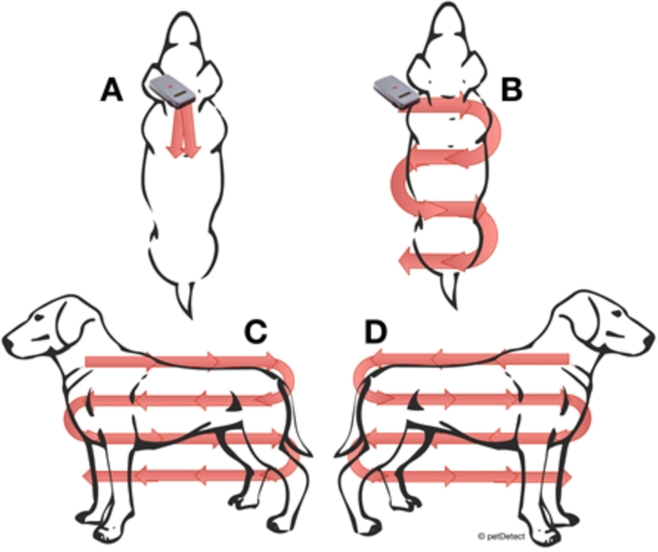
  - Scan once by scanning horizontally, then again vertically if no chip was found.
**Note: After the scanner is turned on, the button must be held down during the entire scanning reading or it will not detect the presence of a microchip.
- Contact Riley County Police Department – Dispatch at 785.537.2112
  - File a lost pet report.
  - If owners is known, notate information on Good Samaritan Physical Exam Form & Release.
- Provide Good Samaritan information on what to do with lost pets in Manhattan, KS and community cats, if applicable.
  - T. Russell provides service to the City of Manhattan and areas of Riley County that are not within city limits. They will accept dog GSAs that are healthy and considered a nuisance to the community. Client-owned animals that are healthy can be surrendered by their owner by scheduling an appointment directly with the shelter (TRRAS).
  - There is currently limited coverage available in some communities. These situations will be evaluated on a case-by-case basis once the appropriate officials are contacted.
  - Stray, uninjured animals found in Pottawatomie County, and the cities of Riley, Wamego, Ogden, and Saint George should be reported to the designated law enforcement official for that community.
  - The following service and reporting agencies can be contacted based on the location the GSA was found:

    - Geary County: Geary County Sheriff: 785-238-2261
    - Junction City: JC Animal Shelter: 785-238-1359 or JCPD: 785-762-5912
    - Leonardville: City of Leonardville: 785-293-5211 or RCPD: 785-537-2112 Ext 0
    - Manhattan: T. Russell Reitz: 785-587-2783 or RCPD: 785-537-2112 Ext 0
    - Ogden: City of Ogden Animal Control: 785-539-0311 or RCPD: 785-537-2112 Ext 0
    - Pottawatomie County: Pottawatomie County Sheriff: 785-457-3481
    - Randolph: RCPD: 785-537-2112 Ext 0
    - Riley County (only areas that are unincorporated): T. Russell Reitz: 785-587-2783 or RCPD: 785-537-2112 Ext 0
    - Riley (City of Riley): City of Riley: 785-485-2802 or RCPD: 785-537-2112 Ext 0
    - Saint George: St. George PD: 785-494-2556
    - Wamego: Wamego PD: 785-456-9553
    - Fort Riley: Fort Riley Stray Facility: 785-239-6183
  - GSAs not eligible for transfer to one of the above agencies will be reviewed on a case-by-case basis.
  - When the animal is stable, the VHC will release the animal to a Kansas licensed shelter. If the Good Samaritan wishes to apply to adopt the animal, they must contact the responsible party for adoption instructions.
  - Do not post pictures or information of the GSA online.

- Perform physical exam and triage
  - If the animal is admitted with non-critical disease or injury, provide basic medical interventions and transfer to responsible party as soon as possible. If presented after hours, transfer to Pet Health the following business day. There may be an ACO available during daytime weekend days, so animals meeting this criteria may be able to be transferred to T. Russell animal shelter on the weekend if it is one they are willing to take.
  - For severe pain, injury, or disease, provide basic medical interventions in order to make the animal comfortable. Laboratory tests/radiographs should not be performed unless they are vital to the outcome of the patient. If treatment is estimated to exceed $200.00, clinician must obtain approval from the section head, Hospital Administrator, or Associate Dean of Clinical Programs. Additional treatment will be directed by appropriate animal shelter based on shelter with jurisdiction.
  - For liability reasons, if euthanasia is warranted, two DVMs must agree that euthanasia is in the best interest of the patient and both clinicians must sign the Good Samaritan Intake form. A final patient report must be completed by the primary clinician on the case. This information will be sent to the responsible party so they can maintain in their animal logs and notify inquiring owners of outcome.
- Patient can be housed in a cage, Ward 2, or a Run with an appropriate ID card and identification collar. Species and/or age-appropriate food, water, bedding, external heat, and litter box must be provided to the patient as appropriate.
- Contact responsible party (contact information noted in medical record if available) to update about admission and condition of animal
  - Responsible party may agree to arrange discharge of animal.
  - Responsible party may agree to transfer ownership/account information and take over financial responsibility of patient.
  - Responsible party may need to discuss case further with shelter veterinarian to determine whether appropriate care can be continued at the shelter or not. While waiting, patient may be transferred to account of responsible party.

Transfer
Every effort should be made to transfer animals to a responsible party as soon as possible. Using surplus resources on a single GSA patient detracts from available resources for all other GSA patients.
If the responsible party is unable to be reached (most often due to restricted hours of operations), then attempt to contact again during normal business hours.
- The patient will continue to be utilizing Good Samaritan funds until the responsible party is made aware of admittance!
- If the patient hospital admission will extend beyond the receiving clinician’s shift, transfer to the appropriate VHC service area to continue care is needed. The transfer process is very important to ensure appropriate patient care and communication with designated receiving service. Complete the transfer form and document all appropriate actions. GS intake and release forms should also be started by the intake service to the extent they can complete it, but do not finalize it as it will be added to and finalized by the service that released the patient to a responsible party or when claimed by its owner. It is important that the receiving service be notified that they are being transferred a Good Sam patient.

- Owner
  - Possible owners should be made aware of which responsible party the animal has been/will be transferred to. Arrangements for reclaim will take place between the responsible party and the potential owner.
- Shelter with Jurisdiction
  - In the event a GSA was found in an area where the local government provides animal services, the animal service provider becomes the responsible party.
  - The responsible party will fill out the “Release to Animal Control Officer Authorization” section of the Good Samaritan Physical Exam Form & Release, so an account can be created, and patient/charges can be transferred.
  - A Good Samaritan Animal cannot be transferred until the clinician overseeing the case has confirmed admittance and condition of the animal with the responsible party.
- Shelter/Rescue
  - In the event a GSA was found in an area where the local government does NOT provide animal services, an outside shelter or rescue may become the responsible party.
  - Commonly, Riley County Humane Society (RCHS), which is a 501c3 non-profit (foster based) rescue organization run entirely by volunteers, becomes the responsible party in these instances. If RCHS is unable to intake the animal, the clinician overseeing the case will contact the section head, Hospital Administrator, or Associate Dean of Clinical Programs, who will reach out to shelter partners that may be able to intake the animal.
  - Once a shelter or rescue has been confirmed to become the responsible party, a representative will fill out the “Release to Shelter” section of the Good Samaritan Case Summary so an account can be created, and patient/charges can be transferred.
- Deceased on Arrival (DOA)/Died in care
  - Receiving clinician will contact responsible party of the animal’s outcome.
    - Responsible party may elect to pick up the remains or proceed with disposal via the VHC.
  - Remains pick up will be coordinated by the responsible party.
  - Remains must be picked up within 48 hours and should be stored in JSL freezers.
Financial
All services/charges will be entered into VetStar by the Emergency/Discharge Desk personnel from tic sheets provided by the responsible clinician or student or directly entered in VetStar. There is a limit of $200 for expenses toward GSA patients. If this amount is exceeded, the requesting clinician must obtain approval from the section head, Hospital Administrator, or Associate Dean of Clinical Programs for charges in excess of $200.00 incurred when treating an animal. Account should be transferred from Good Samaritan to owner, who will then be responsible for all charges.
If an individual or group has expressed an interest in providing funds for the care of a GSA, their payment will be applied directly to the VetStar Good Samaritan account for that patient. When the animal is stable, the VHC is required to release the animal to a Kansas licensed shelter. If the fund provider wishes to apply to adopt the animal, they must contact the shelter for adoption instructions.
At times there may be circumstances when outside entities may desire to provide funds to the VHC specifically for the care of these animals before they are released to the shelter. When this occurs, it is understood by the fund provider that they do not own the animal and would need to follow the same process as any other entity or person would to adopt the animal from the shelter.

