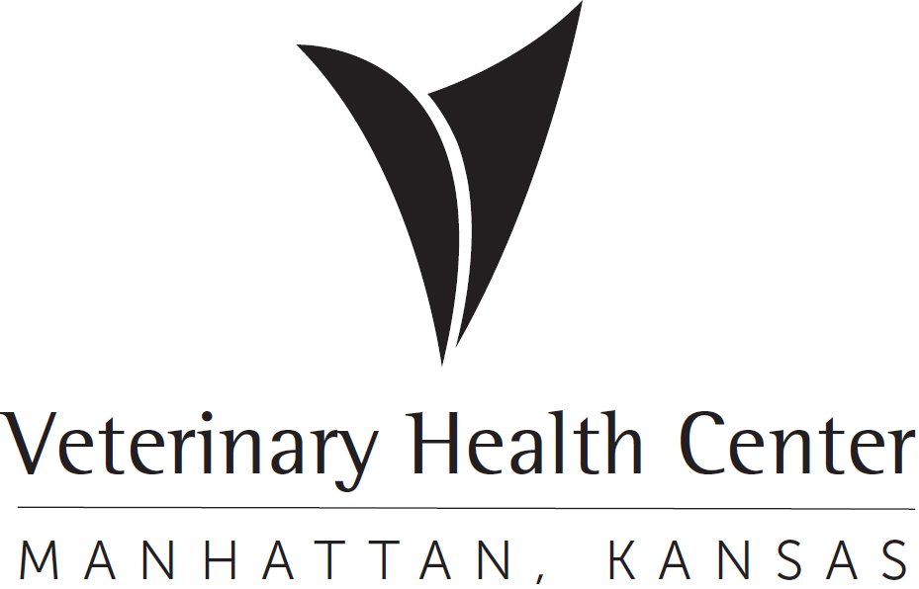 | OFFICIAL PROTOCOL

EXOTICS/WILDLIFE GOOD SAMARITAN PROTOCOL

Purpose: To guide VHC staff on the intake, management, and transfer of all exotic/wildlife good Samaritan animals. The VHC will provide care for most species, other than those species that are otherwise noted in this document, until they can be transferred to the appropriate party.

Domesticated/Pet Species:
Abandoned/relinquished pets will be received and treated similarly to SA Good Sam animals (See Good Samaritan Animals Protocol – Clinical Management). These animals will be received by the Exotics Service during normal business hours, or by the Emergency Service after hours.

Local animal shelters/rescues may decline intake of exotics species due to lack of available space, or lack of materials to care for these animals. In these cases, the VHC will continue to care for these animals until a rescue or owner can be determined.

Wildlife Species:
In cases regarding wildlife, it is the duty of VHC staff and faculty to provide reasonable veterinary care and/or humane euthanasia for wildlife species. They should also be able to provide basic community education regarding orphaned or otherwise healthy animals that do not require veterinary care.

RECEIVING
- Phone calls
- Good Samaritans calling regarding obviously sick/injured wildlife may be advised to bring these animals to the VHC provided they are not a species that the service does not see (venomous snakes, wild deer outside of section 8, other dangerous species)
- Good Samaritans calling regarding orphaned or otherwise healthy animals should first be directed to call Milford Nature Center or another licensed rehabilitation center first so that they may provide education on orphaned wildlife. If the animals are truly orphaned or in need of medical care, the rehab center may advise the Good Samaritan to bring the animal to the VHC.
  - If these calls take place outside of normal business hours, the receiving service may provide client education or advice on the care of these animals.
- In-clinic receiving
- Wildlife brought the VHC during normal business hours (8:00am to 5:00pm) will be received by Exotic/Zoological service.
- After hours may be received by the emergency service, except in some special circumstances**.
- The electronic medical record created by VHC Client Services will include 2 documents:
  - Good Samaritan Physical Exam Form & Release
  - Good Samaritan Client Intake Form
    - Good Samaritan information: Name, Address, Phone number
    - Where the animal was found (address, cross streets, landmarks) consistent with the county reporting document to support why it was a community nuisance or danger. This is essential information at the time of intake.
    - Date and time animal was found.
    - The Good Samaritan should be asked if anyone has been bitten or scratched. If yes, the injured person’s name and contact information and when it occurred should be collected at the time of presentation.

*Please Note:

- Good Samaritans will not be given updates on the animal after it has been relinquished to the VHC.

- Do not post pictures or information of the Good Sam Animal online. This is a violation of CVM policy.

CLINICAL MANAGEMENT
- Wildlife patients will be treated according to the attending clinician's recommendation. Considerations for treatment of wildlife include prognosis, the ability of the animal to be returned to the wild (able to hunt, reproduce, etc.), if the animal can be transferred to a licensed wildlife rehabilitator, and whether the animal is an invasive/nuisance species.
- All wildlife species will need to be examined and housed in the wildlife ward (E117A) or the quarantine area if indicated (J183). These animals should never be housed or examined in rooms used for client-owned patients.
- A physical exam will be performed and the “Clinical Staff” portion of the “Good Samaritan Client Intake Form” should be completed.
  - Treatment and/or euthanasia will be pursued at the discretion of the attending clinician.
- Animals that do not require medical intervention, or those that are done receiving treatment, will need to be transported to a licensed rehabber as soon as possible. The VHC does not retain any permits allowing us to house or release wildlife that is not receiving medical treatment.
- Deceased patient care
  - Deceased wildlife should be placed into the green “Biobags”. These are the only bags that are safe to go into the digestor. No labels or tags should be placed on the bag. No submission forms are necessary.
  - Please take it to the necropsy fridge as you would any other euthanized animal. The body should be placed into a green “Bio Bag” with no labels or stickers and then into the “Good Sam Digest” natural decomposition bin.

TRANSFER AND TRANSPORT
- For animals that need any minor medical care (short course of antibiotics, feeding orphaned animals, minor wound management) a licensed rehabilitator will need to be located, and transport will need to be arranged as soon as possible.
- A current list of all licensed rehabbers in Kansas can be found on the KDWP website at “”https://ksoutdoors.com/Services/Rehabilitation/List-of-current-Kansas-Rehabilitators"
  - Many rehabbers only receive specific species, or species from specific counties which are listed on this page.
- A “Wildlife Hotline” is also available as an option for finding available rehabbers. A message may be left at the following phone number: (785) 575-1991. This voicemail is checked regularly by volunteers who may be able to assist in the transport of animals to rehabbers.
  - These volunteers may be able to pick up animals directly, but there are occasions where transport to a drop-off location may need to be arranged. Gage Animal Hospital in Topeka is the drop-off location for these services.
- In situations where pickup from the VHC cannot be arranged, the Shelter Medicine service can be contacted to assist in the transport of animals.
  - The staff/faculty that is responsible for the animal will need to coordinate with the receiving rehabber and the Shelter Medicine schedule to arrange pick up/drop-off of all animals.
- Please indicate on the “Good Samaritan Physical Exam/Release form” if the animal was released to a rehabber or euthanized.

FINANCIAL
All services/charges will be entered into VetStar by the responsible staff member. There is a limit of $200 for expenses toward Good Sam patients. If this amount is exceeded, the requesting clinician must obtain approval from the section head, Hospital Administrator, or Associate Dean of Clinical Programs and a green sheet will need to be submitted specifying the cost and what funds will be used. If an individual or group has expressed an interest in providing funds for the care of an animal, their payment will be applied directly to the appropriate VetStar Good Samaritan account for that patient. When/if the animal is done receiving medical treatment, it will need to be released to a licensed wildlife rehabilitator.

SPECIAL CIRCUMSTANCES DEFINED
**Venomous Snakes (Rattlesnakes, Copperheads): Under no circumstances should venomous snakes be admitted to the VHC.

**Raptors, Corvids (crows and blue jays): See HPAI protocol for instructions on receiving birds at a higher risk of transmitting HPAI.

**Rabies vectors (Skunks, racoons, bats, foxes): These animals are considered at a higher risk of contracting rabies. For this reason, special precautions will need to be taken when receiving these animals. Full PPE (gowns, gloves, masks, face shield and/or goggles) will need to be worn at all times. If there has been an incident of possible human exposure to these animals, they will need to be euthanized and submitted for rabies testing. See Rabies Suspect Intake Protocol and VHC Rabies Protocol. Non-sick or orphaned animals will need to be:
- Bats: Any bat brought into the VHC will need to be euthanized immediately and submitted for rabies testing.
- Skunks/raccoons/foxes: Good Samaritans should be discouraged from bringing in these animals except in situations where the animal is suffering or there is possible human exposure to rabies. Good Samaritans should be discouraged from attempting to capture these animals themselves. They should be directed to call animal control or the game warden for their county to collect any sick/injured animals. For non-sick or orphaned animals, the client should call a local wildlife rehabber for guidance.
  - Raccoons: Because of the risk of Baylisascaris infection, racoons will need to be euthanized upon intake. PPE will need to be worn when retrieving these animals. They will need to chamber induced with inhalant anesthetics within the carrier they are received. Do not attempt to take these animals out of the carrier. Once the animal is at an appropriate anesthetic depth, it can be transferred directly into another plastic bag and euthanized. The body should be double bagged and taken to the necropsy fridge for rabies testing (if indicated) or disposal. The room and carrier will need to be terminated with a 1:20 bleach dilution. All PPE will need to be disposed of in the biohazard trash.
**Deer: The VHC will only accept wild deer that are obtained within Management unit 8 (East of highway 81, north of highway 4, west of highway77, and south of Nebraska border). Animals will need to be received through Tier 1 at the back of the building and brought directly into J182. PPE will need to worn at all times when handling these animals.

**Wild rabbits: Clients should be discouraged from bringing wild rabbits into the VHC. Good Samaritans with orphaned wild rabbits should be directed to call a local wildlife center/rehabber directly. For injured rabbits, or situations in which the god Samaritan is unable to transfer these animals, we can receive them. The animals will need to be brought directly to the wildlife room (E117A), and PPE will need to be worn at all times when handling these animals. Staff/faculty that are also seeing pet rabbits during the same workday are discouraged from handling wild rabbits.

