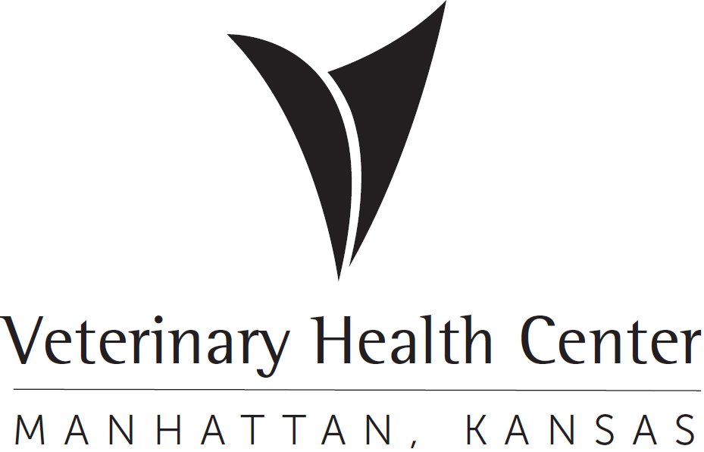 | OFFICIAL PROTOCOL

ANIMAL SCIENCES AND INDUSTRY (ASI) DISCOUNT PROTOCOL

Purpose: The VHC offers ASI Units a discount on veterinary services as a professional courtesy and to enhance clinical training opportunities for senior veterinary students. The discount is provided with the understanding that ASI Units will cooperate with VHC clinicians in making animals available for clinical training at mutually agreeable times.

This protocol is valid for one year beginning July 1, 2023 and can be renewed annually by mutual agreement.

I. Units Included: Dairy, Cow/Calf, Purebred Beef, Beef Research Unit (Feedlot), Horse Unit, Stocker Unit, Swine Unit

II. Access to Animals for Teaching: In general, VHC clinicians will seek opportunities to use ASI Unit animals for clinical training when food animal or equine ambulatory services are not busy. Clinicians will contact the Unit Manager to discuss opportunities for clinical training. Unit Managers may contact VHC clinicians they are aware of clinical training opportunities that would be beneficial for veterinary students. VHC clinicians and Unit Managers must have a clear understanding that such visits are for clinical training purposes and not for provision of veterinary services.

III. Billing: The VHC will discount all veterinary services provided to ASI Units by 40%. The business office will then send the ASI units an invoice at the end of each billing cycle.

