**Veterinary Health Center**

**Infection Control Plan**

**Reviewed September 2022**

<https://iweb.vet.k-state.edu/depts/vhc/pdf/Infection_Control_Plan.pdf>



**Mission Statement**

The Veterinary Health Center’s mission is to provide superior veterinary medical education, quality patient care and exceptional customer service in a caring environment.

**Printed copies available:**

Small Animal ICU (B149 Mosier) Emergency/Discharge Desk (B141 Mosier)

Large Animal Records Room (J104 Mosier) Large Animal Isolation (J191 Mosier) Director’s Office (A106 Mosier)

Contents

Infection Control Plan 4

Personal Protective Actions and Equipment 4

Hand Hygiene 4

Gloves 4

Facial and Eye Protection 5

Respiratory Tract Protection 5

Protective Outerwear 5

Protective Actions during Veterinary Procedures 6

Patient Intake 6

Animal Handling and Injury Prevention 6

Examination of Animals 7

Injections, Venipuncture, and Aspiration Procedures 7

One-Handed Scoop Method for Recapping Needles: 7

Dental Procedures: 7

Resuscitation: 7

Obstetrics 7

Necropsy 7

Diagnostic Specimen Handling 8

Wound Care and Abscesses 8

Feeding of raw meat diets 8

Environmental Infection Control 8

Cleaning and Disinfection of Equipment and Environmental Surfaces 8

Isolation of Infectious Animals 8

Handling Laundry 9

Spill Response and Decontamination 9

Veterinary Medical Waste 9

Rodent and Vector Control 10

Other Environmental Controls 10

Occupational Health 10

Infection Control and Employee Health Management 10

Record Keeping 11

Pre-Exposure Rabies Vaccination 11

Tetanus Vaccination 11

Influenza Vaccination 11

Documenting and Reporting Exposure Incidents 11

Staff Training and Education 11

Pregnant and Immunocompromised Personnel 11

Contact Information 12

Emergency Services Telephone Numbers 12

State and Public Health Resources 12

Environmental Protection Agency 13

KSU Environmental Health and Safety Office 13

Kansas Department of Health and Environment 13

Animal Control 14

Reportable or Notifiable Veterinary Diseases 14

Regulations/Information 15

Animal Control 15

CVM Protocol on Biohazardous Animal Waste 15

Occupational Health and Safety 16

Rabies 17

Veterinary Standard Precautions 17

Biosecurity Protocols and Procedures 18

Large Animal 18

Large Animal General Stall Cleaning Procedure 18

Equine Services Biosecurity Standard Operating Procedures 18

Livestock Services Biosecurity Standard Operating Procedures 22

Large Animal Isolation Procedures 26

Small Animal 28

Small Animal General Cleaning Procedures 28

Exam Room Cleaning/Disinfection Procedure after Infectious Suspect Patient Exposure 31

Small Animal Surgery Cleaning Procedures 31

Intensive Care Unit Cleaning Procedures 34

Isolation Cleaning Procedures 37

Foot and Mouth Disease Prevention for Visitors Traveling To the United States from Infected Regions of the World 39

Primate (Non-Human) Occupational Safety 40

Standard Operating Procedure for Sharps Container Removal and Restocking in the Veterinary Health Center 45

Rabies Vaccination Post-Exposure Protocol 48

Appendix A 51

Calf Isolation Procedures 51

Appendix B 52

EPA Registered Disinfectants used in the VHC 52

Antimicrobial Spectrum of Disinfectants 56

Select Zoonotic Diseases of Companion Animals 59

Zoonotic Disease Fact Sheet 63

**Veterinary Health Center**

# Infection Control Plan

Date of Plan Adoption: December 2009

Date Updated: September 2022

Date of Next Review: August 2023

Infection Control Officer: Dr. Elizabeth Davis, Associate Dean of Clinical Programs

This plan will be followed as part of our practice’s routine procedures. The plan will be reviewed at least annually.

## Personal Protective Actions and Equipment

Hand Hygiene: Perform hand hygiene between examinations of individual animals or animal groups (e.g. litters of puppies or kittens, groups of cattle) and after contact with feces, body fluids, vomitus, exudates, and articles contaminated by these substances. Perform hand hygiene before eating, drinking, or smoking; after using the toilet, cleaning/disinfecting animal cages, contact with environmental surfaces in animal-care areas, handling laboratory specimens and/or removing gloves; and whenever hands are visibly soiled. Keep fingernails short. Do not wear artificial nails or hand jewelry when handling animals. Keep hand-washing supplies stocked at all times.

All Staff responsible: Veterinarians, Veterinary students, Veterinary Nurses, Veterinary Assistants and Animal Caretakers

**Correct hand-washing procedure**:

* Wet hands with warm/hot running water
* Place soap in palms
* Rub hands together to make a lather
* Scrub hands vigorously for 20 seconds
* Rinse soap off hands
* Dry hands with a disposable towel
* Turn off the faucet using the disposable towel to avoid hand contact

**Correct use of hand rubs**:

* Place alcohol-based hand rub in palms
* Apply to all surfaces of hands
* Rub hands together until dry

Gloves: Gloves are not necessary when examining or handling healthy animals. Wear gloves when performing soft tissue or body fluid aspirations and while performing venipuncture on animals suspected of having an infectious disease. Wear gloves when touching feces, body fluids, vomitus, exudates, and non-intact skin. Wear gloves for dentistry, resuscitations, necropsies, and obstetrical procedures; when cleaning/disinfecting cages, litter boxes, environmental surfaces and equipment in animal areas and when handling dirty laundry, handling diagnostic specimens (e.g., urine, feces, aspirates, or swabs), and/or when handling an animal with a suspected infectious disease. Wear gloves if you have wounds or compromised skin integrity of the hands. Change gloves between examination of individual animals or animal groups (e.g., a litter of puppies), between dirty and clean procedures performed on the same patient and/or when torn. Gloves should be removed promptly; in a manner to limit skin contact with soiled gloves and disposed of after use. Disposable gloves should not be washed and reused. Hands should be washed immediately after glove removal.

Facial and Eye Protection: Wear facial and eye protection for the following procedures: lancing abscesses, flushing wounds, dentistry, nebulization, suctioning, lavage, obstetrical procedures, and necropsies. Use a face shield or goggles with a surgical mask whenever splashes or sprays are likely to occur. Goggles provide superior protection from infectious materials compared to safety glasses, which are designed for impact protection. Goggles should be worn under face shields. Of particular note: Goggles are required when working with animals suspected to have rabies or any other infectious disease that could be transferred by corneal or conjunctival contact.

Respiratory Tract Protection: Use a molded particulate respirator (N99) located in G112-A when exposure to airborne pathogens is likely. Use respiratory protection following OSHA regulations. Refer to respiratory protection flow charts.

Face fitting respirators are to be used for protection when working with hazardous materials. Respirator Physical training and fit testing are required for use of face-fitting respirators in compliance with Kansas State University Environmental Health and Safety Respiratory Protection Protocols. The protocols require an annual medical determination by Lafene Health Center physicians that the worker is healthy and physically able to perform the work and wear the equipment. The protocol also requires that qualitative fit testing be conducted prior to issuing a worker a respirator and every twelve months thereafter. Supervisors are responsible for assuring and documenting that annual training and fit testing for each supervisee are accomplished.

Protective Outerwear: Wear a protective outer garment such as a laboratory coat, smock, non-sterile gown, or coveralls when attending animals and when conducting cleaning chores in animal areas. Wear gloves when performing soft tissue or body fluid aspirations and while performing venipuncture on animals suspected of having an infectious disease. Protective outerwear should be changed after handling an animal with a known or suspected infectious disease, working in an isolation room, after performing a necropsy or other high-risk procedure, and/or whenever soiled. Shoes or boots should have thick soles and closed toes and be impermeable to water and easily cleaned. Disposable shoe covers or washable boots should be worn when heavy quantities of infectious materials are present or expected. Impermeable outwear should be worn when heavy quantities of infectious materials are expected. Garments should be changed and laundered daily, and whenever they become visibly soiled or contaminated. Coveralls should be changed and boots cleaned between farm premises/facilities/locations/herds. Protective outerwear should not be worn outside of the work environment. Keep clean outer garments available at all times.

Staff responsible: Veterinarians, Veterinary Students, Veterinary Nurses, Veterinary Assistants and Animal Caretakers

## Protective Actions during Veterinary Procedures

Patient Intake: Avoid bringing aggressive or potentially infectious small animals in through the reception area. If they must come through the main entrance, carry the animal, place it on a gurney or in a roll cage so that it can be taken directly into a designated examination room. Large animals will be moved at the direction of section faculty or staff and must be under control or containment at all times.

Animal Handling and Injury Prevention: Take precautions to prevent bites and other animal-related injuries. Identify aggressive animals and alert clinic staff. Use physical restraints, muzzles, bite-resistant gloves, and sedation or anesthesia as necessary in accordance with practice policies. Plan an escape route when handling large animals. Do not rely on owners or untrained staff for animal restraint.

* If there is concern for personal safety, notify: Supervisor, Faculty Section Head, Hospital Administration
* When injuries occur, wash wounds with soap and water, then immediately report incident to: Supervisor, Faculty Section Head, Hospital Administration and then College of Veterinary Medicine (CVM) Human Resources
* If medical attention is needed contact:
  + Life Threatening Injuries: *Call 911 or arrange immediate transportation to Ascension Via Christi – 1823 College Avenue, Manhattan, KS 66502
  + Non-Life Threatening Injuries:
    - Employees & Student Workers
      * Complete the incident report through the online portal: <https://kstate.service-now.com/webforms?id=incident_reporting_form>
      * The employee and supervisor should contact the 24/7 Nurse Triage Program at 833-756-2007 to receive additional health related instructions or care.
      * If the employee’s supervisor is not available a member of the CVMHR team can assist during normal business hours 785-532-3042 or email [cvmhr@vet.k-state.edu](mailto:cvmhr@vet.k-state.edu).
      * Appointments are usually facilitated through Ascension Via Christi Occupational Health – 315 Seth Childs Rd. Manhattan, KS 66502 (North of Home Depot).
      * KSTAT Urgent Care – 711 Commons Pl, Manhattan, KS 66502
    - Veterinary Students
      * Call Lafene Health Center – 532-6544

1105 Sunset Ave. Manhattan, KS 66502

* Bite incidents will be reported to:
  + VHC Hospital Administration
  + Riley County Animal Control – 785-537-2112. Ask for Dispatch. They will take your information and contact animal control. Make sure you tell the Dispatcher you actually need to speak to Animal Control so you can relay the appropriate message. (If you do not speak to an Animal Control employee, the Dispatcher may think it is a Good Sam pickup.)

Examination of Animals: Patients must be adequately restrained to prevent human exposures from bites and scratches. Sedation should be used when appropriate. Keep potentially infectious animals in a designated examination room or stall until diagnostic procedures and treatments have been performed.

Injections, Venipuncture, and Aspiration Procedures: Trained personnel should restrain animals to minimize needle stick injuries due to animal movement. Do not: bend needles, pass an uncapped needle to another person, walk around with uncapped needles, remove an uncapped needle from the syringe by hand, place a needle cap in the mouth. Do not recap needles (unless the one-handed scoop method is used).

### One-Handed Scoop Method for Recapping Needles:

* Place the cap on a horizontal surface
* Hold the syringe with attached needle in 1 hand
* Use the needle to scoop up the cap without use of the other hand
* Secure the cap by pushing it against a hard surface

Dispose of all sharps in designated containers. After injection of live vaccines or performing soft tissue or body fluid aspirations, dispose of the used syringe with the needle attached in a sharps container. Otherwise, you may remove the needle with forceps and throw the syringe away in the trash. Do not transfer sharps from one container to another. Replace sharps containers before they are completely full. Place used containers in designated areas for pickup by Animal Caretaker, Veterinary Nurse, or Veterinary Assistant Staff who will transfer them to room G112-D (Stairwell 105 – Outside biohazard pickup) daily for pickup by University Environmental Health and Safety personnel. Designated drop off areas for used containers are:

* B116 – Small Animal Services
* H116 – Equine Services
* J113 – Livestock Services
* J191 – Large Animal Isolation

Staff responsible: Veterinarians, Veterinary students, Veterinary Nurses, Veterinary Assistants, Animal Caretakers, Pharmacists, Pharmacy Technicians

Dental Procedures: Wear protective outerwear, head cover, gloves, and facial protection when performing dental procedures or when in range of splashes or sprays (such as when monitoring anesthesia).

Resuscitation: Wear gloves and facial protection. Use a manual resuscitator, anesthesia machine, or ventilator to resuscitate animals. When possible bag-mask or mouth-to-snout ventilation. Reference: Veterinary Emergency Critical Care Society 2012 – Page S28:

<https://onlinelibrary.wiley.com/doi/epdf/10.1111/j.1476-4431.2012.00753.x>

Obstetrics: Wear gloves or shoulder-length sleeves, facial protection, and impermeable outerwear.

Necropsy: All hospital necropsies are performed by the Kansas State Veterinary Diagnostic Laboratory. Post-mortem tissue harvest prior to necropsy will be performed under direct faculty supervision using gloves, facial protection and outerwear.

Diagnostic Specimen Handling: Wear protective outerwear, gloves and eye protection as necessary. Handle feces, urine, vomitus, aspirates, and swabs as if they were infectious. Discard gloves and perform hand hygiene before touching clean items (e.g., medical records, keyboard, telephone). Eating and drinking are not allowed in laboratories.

Wound Care and Abscesses: Wear protective outerwear as indicated and gloves for debridement, treatment, and bandaging of wounds. Facial protection should also be used when lancing abscesses or lavaging wounds. Discard used bandages as indicated. Handle used scissors, clipper blades and other equipment as if contaminated. Perform hand hygiene after removing gloves.

Feeding of raw meat diets**:** Raw meat-based diets for cats and dogs may contain a variety of enteropathogens including *Salmonella* spp*, Clostridium difficile, Clostridium perfringens, Escherichia coli* and *Campylobacter* spp. Animals fed raw diets may shed high levels of pathogens in their feces, therefore, raw diets and feces from animal fed raw diets may pose a risk to other patients, hospital personnel, and may contaminate the environment. As a result:

* Raw meat diets will not be fed to any dog or cat at the VHC. Owners who request that raw meat diets be fed to their pets will be informed that the risks associated with such diets precludes their use in the VHC.
* Infectious disease should always be strongly considered in any animal that develops diarrhea while on a raw meat diet. Patients who develop signs of systemic illness, have severe diarrhea, or are suspect of having infectious disease for other reasons, should be placed in isolation.

## Environmental Infection Control

Cleaning and Disinfection of Equipment and Environmental Surfaces: Wear gloves when cleaning and disinfecting cages and other surfaces in animal areas. Perform hand hygiene afterwards. Clean surfaces and equipment to remove organic matter, and then disinfectant according to manufacturer’s instructions. Clean and disinfect animal cages, gurneys, roll cages, toys, and food and water bowls between uses and whenever visibly soiled. Clean litter boxes at least once daily. Keep clean items separate from dirty items.

Isolation of Infectious Animals: Put animals with an infectious disease in isolation as soon as possible. Clearly mark the room or cage to indicate the patient’s status, and describe additional precautions. Limit access to the isolation room. All persons entering Small Animal Isolation will swipe their CVM ID card at the reader located outside the isolation door (B156 Mosier). The entry log will be generated daily by CVM Security and filed in the Hospital Director’s Office (A106) by the Assistant to the Director. All persons entering a Large Animal Isolation stall will swipe their CVM ID card at the reader located outside the isolation supply room door (J191 Mosier). The entry log will be generated daily by Security and kept in the Hospital Director’s Office (A106) by the Assistant to the Director. Keep only the equipment needed for the care and treatment of the patient in the isolation room, including dedicated cleaning supplies. Personal Protective Equipment (PPE) should be donned immediately prior to care of the animal in isolation and removed just prior to leaving isolation. Discard gloves after use. Leave reusable personal protective equipment (e.g., gown, mask) in the isolation room. Clean and disinfect or discard protective equipment between patients and whenever contaminated by body fluids. Disassemble and thoroughly clean and disinfect any equipment that has been used in the isolation room. Place potentially contaminated materials in a bag before removal from the isolation room.

Staff responsible: Faculty Section Heads, Assistant to the Director and/or Hospital Administrative Assistant, Veterinarians, Veterinary Students, Veterinary Nurses, Veterinary Assistants, and Animal Caretakers

**Suspect Animal:** When working with animals that may have a zoonotic, infectious disease outside of isolation unit, a clear, warning sign should be placed on the cage or stall which describes the condition of concern and additional precautions that are needed. In addition, an infectious disease log sheet must be maintained and attached outside the stall or cage. All individuals working with the animals must list their name, date of the contact, phone number and exposure level. The log becomes part of the medical record. Warning signs are available in the Director’s Office. Logs are available in the Medical Records. **Once an animal is confirmed to have an infectious disease it must be transferred to an isolation ward or stall**.

Handling Laundry: Wear gloves and protective outerwear when handling soiled laundry. Check for sharps before items are laundered. Wash animal bedding and other laundry in the facility with standard laundry detergent and completely machine dry at the highest temperature suitable for the material. Use separate storage and transport bins for clean and dirty laundry. Outerwear to be laundered at home should be transported in a plastic bag, kept separate from household items, washed separately and then thoroughly machine dried. Potentially infectious laundry will be autoclaved prior to washing.

Spill Response and Decontamination: Immediately contain spills and splashes of potentially infective substances with absorbent material (e.g., paper towels, sawdust, cat litter). Use PPE to protect against the potentially infective agent and the cleaning/disinfectant to be used. Consult and follow the label recommendations. When handling spills that are located indoors or in association with small animal patients, pick up material, seal in a leak-proof plastic bag, and clean and disinfect the area. Spills associated with large animal patients should be picked up, sealed in a leak-proof plastic bag and placed in designated containers in the LA isolation unit and the area cleaned and disinfected. Keep clients, patients, and employees away from the spill area until disinfection is completed.

Veterinary Medical Waste: Medical services waste is any solid waste material which is potentially capable of causing disease or injury and which is generated in connection with human or animal care through inpatient and outpatient services.

Infectious medical waste is medical services waste that includes any substance that poses a potential risk of transferring disease to humans or animals. Infectious medical waste should be placed in sealed biohazard bags and taken to the necropsy area for autoclaving and destruction using the process outlined below.

All infectious medical waste must be placed in autoclave bags at their point of origin, with indicator tape and KSVDL Biohazard tag ties on them. The bags need to have a 1-inch diameter opening in the tie of the bag to allow steam in. A completed KSVDL Biohazard tag must be attached to each bag and the bags must be placed in a wheeled waste transfer cart at their point of origin for transfer to Red Bin labeled VHC located north of the Mosier D-111 outside freezer door for holding until Autoclave processing is available. The tags and the waste transfer cart can be found in Mosier Hall Room G-112D/SW105. Tags are also located in the hallway by Necropsy.

Biohazard bags can be taken to the KSVDL receiving area in wheeled transfer carts for Autoclave Processing any day of the week before 10:30 am (subject to changes due to holidays or mechanical malfunction). Bags are dropped off in the aforementioned bin by D-111 freezer door. The wheeled transfer cart should be returned immediately to Mosier G-112D/SW105.

Additional information may be found in the **CVM Protocol on Biohazardous Animal Waste** located on page 16 of this document.

Solid waste from small animals that is not potentially infectious and is not classified as sharps should be placed in clear plastic bags for disposal in a trash dumpster. Fecal and urine waste from large animals must be collected and placed in approved disposal containers located in the Large Animal Hospital.

Uncontaminated broken glass needs to be packaged in puncture proof packaging and taken to the dumpster. Custodians are not responsible for disposing of broken glass.

Staff Responsible: Veterinarians, Veterinary Students, Veterinary Nurses, Veterinary Assistants, Animal Caretakers

**Parasite Control on Animals: All animals with evidence of parasitism must be treated prior to VHC hospitalization. A clinician should select the treatment which will eliminate the parasites as quickly as possible in order to minimize the chances of infestation and transmission.**

Rodent and Vector Control: Seal entry portals, eliminate clutter, and sources of standing water, keep animal food in closed metal or thick plastic covered containers, and dispose of food waste properly to keep the facility free of wild rodents, mosquitoes, and other arthropods. Check and treat animals entering the veterinary facility for vector parasites. Staff Responsible: CVM Facilities, Veterinary Nurses, Veterinary Assistants and Animal Caretakers

Other Environmental Controls: There are designated areas for eating, drinking, smoking, vaping application of make-up, and similar activities. These activities should not occur in animal-care areas or in the laboratory area. Do not keep food or drink for human consumption in the same refrigerator as food for animals, biologics, or laboratory specimens. Dishes for human use should be cleaned and stored away from animal-care and animal food-preparation areas.

## Occupational Health

Infection Control and Employee Health Management: The following personnel are responsible for development and maintenance of the practice’s infection control policies, record keeping, and management of workplace exposure and injury incidents.

Staff responsible: Hospital Administrator, Hospital Director, CVM Human Resources

Record Keeping: Current emergency contact information is maintained by CVM HR for every employee. Records provided by employees will be maintained on vaccinations, rabies virus antibody titers, and exposure and injury incidents. Changes in health status that may affect work duties should be reported to CVM Human Resources so that accommodations can be considered. Contacts for CVM HR after hours located at the emergency desk - Dr. Priscilla Roddy - Assistant Dean for Administration and Finance.

Pre-Exposure Rabies Vaccination: All staff with animal contact are encouraged to be vaccinated against rabies, followed by periodic titer checks and rabies vaccine boosters, in accordance with the recommendations of the Advisory Committee on Immunization Practices (CDC, 2008). **Note:** Only persons who have received the pre-exposure vaccine series are permitted to work with animals suspected of having rabies. This would include any animals with acute neurologic disease where rabies is considered a differential diagnosis. Additionally, vaccination is also required for any persons who work with wildlife or stray animals. It is the individual’s responsibility to notify the senior clinician if they are unable to care for an animal because of this requirement (Recommendation of the Compendium of Animal Rabies Prevention and Control, 2016). Rabies titer checks should be completed every two years. Rabies vaccination and titer checks provided in accordance with CDC recommendations are provided to VHC employees at hospital expense if done at the Lafene Health Center on the KSU campus. Contact the office of the Hospital Director/Hospital Administrator for more information.

Tetanus Vaccination: Tetanus immunizations should be up to date consistent with human medical recommendations. Report and record puncture wounds, animal bites, and other animal-related trauma. Employees should consult a health care provider regarding the need for a tetanus booster.

Influenza Vaccination: Veterinary personnel are encouraged to receive the current seasonal influenza vaccine. Refer to the Centers for Disease Control and Prevention Web site for guidance

([www.cdc.gov](http://www.cdc.gov)). Lafene offers an annual flu vaccine clinic in the CVM annually. Employees are also able to go to Lafene to receive the flu vaccine.

Documenting and Reporting Exposure Incidents: Report incidents that result in injury or potential exposure to an infectious agent to: Supervisor and Human Resources Professional. Information will be collected using KSU required forms and forwarded to KSU Human Capital Services.

Staff Training and Education: Infection control training and education will be documented in the employee training record.

Pregnant and Immunocompromised Personnel: Pregnant and immunocompromised employees are at increased risk from zoonotic diseases. Employees concerned that work responsibilities may put them at increased risk are to inform their Supervisor and CVM Human Resources so that preventive measures may be taken (such as increased use of PPE). The employee may need to communicate with supervisor and CVM Human resources regarding accommodations advised by their health care provider.

# Contact Information

## Emergency Services Telephone Numbers

**Fire** – Dial 9, then 911

**Police** – Dial 9, then 911

**Animal** **Control** – Contact the VHC Emergency Desk at 2-4100

**Poison Control** – ASPCA Animal Poison Control Center at 1-888-426-4435

Suicide Hotline Dial 9, then 988

## State and Public Health Resources

**Kansas Department of Agriculture** **Kansas Department of Agriculture**

1320 Research Park Dr. **Division of Animal Health**

Manhattan, KS 66502 1320 Research Park Dr.

Phone: 785-564-6700 Manhattan, KS 66502

Fax: 785-564-6777 Phone: 785-564-6601

<http://agriculture.ks.gov> Fax: 785-564-6778

[https://agriculture.ks.gov/divisions-programs](https://agriculture.ks.gov/divisions-programs/division-of-animal-health)

[/division-of-animal-health](https://agriculture.ks.gov/divisions-programs/division-of-animal-health)

**Kansas Board of Veterinary Examiners**

1003 Lincoln St.

P.O. Box 379

Wamego, KS 66547

Phone: 785-456-8781

Fax: 785-456-8782

[vetboard@ks.gov](mailto:KDA.VETBOARD@ks.gov)

<https://kbve.kansas.gov/>

**Public Health Consultants for Zoonotic Diseases**

**Kansas Department of Health and Environment**

**Bureau of Epidemiology and Public Health Informatics**

1000 SW Jackson, Suite 110

Topeka, KS 66612-2221

Phone: 877-427-7313

Fax: 877-427-7318

[kdhe.EpiHotline@ks.gov](mailto:kdhe.EpiHotline@ks.gov)

<https://www.kdhe.ks.gov/1088/Epidemiology-Public-Health-Informatics>

**Public Health Laboratory**

**Kansas Department of Health and Environment**

**Health and Environment Laboratories**

6810 SE Dwight St.

Topeka, KS 66620

Phone: 785-296-1620

[www.kdheks.gov/labs](http://www.kdheks.gov/labs)

## Environmental Protection Agency

**EPA Disinfectant Information**

703-305-1284

[Info_antimicrobial@epa.gov](mailto:Info_antimicrobial@epa.gov)

<https://www.epa.gov/pesticide-registration/selected-epa-registered-disinfectants>

**US EPA Region 7 Office**

11201 Renner Blvd.

Lenexa, KS 66219

Phone: 800-223-0425

Phone: 913-551-7003

Emergency Response Line: 913-281-0991

<https://www.epa.gov/ks/forms/contact-us-about-epa-kansas>

## KSU Environmental Health and Safety Office

**Kansas State University**

**Environmental Health and Safety**

108 Edwards Hall

1810 Kerr Dr.

Kansas State University

Manhattan, KS 66506

Phone: 785-532-5856

Fax: 785-532-1981

[safety@k-state.edu](mailto:safety@k-state.edu)

<https://www.k-state.edu/safety/>

## Kansas Department of Health and Environment

**Kansas Department of Health and Environment**

**Bureau of Waste Management**

1000 SW Jackson, Suite 320

Topeka, KS 66612-1366

Phone: 785-296-1600

[kdhe.bwmweb@ks.gov](mailto:kdhe.bwmweb@ks.gov)

[www.kdheks.gov/waste/index.html](http://www.kdheks.gov/waste/index.html)

## Animal Control

**T. Russell Reitz Animal Shelter Riley County Police Department**

605 Levee Drive. **Animal Control**

Manhattan, KS 66502 Phone: 785-537-2112

Phone: 785-587-2783

[animalshelter@cityofmhk.com](mailto:animalshelter@cityofmhk.com)

<https://www.mhkprd.com/203/Animal-Shelter>

# Reportable or Notifiable Veterinary Diseases

1. State of Kansas Reportable Diseases Statute and Regulations:

<https://agriculture.ks.gov/docs/default-source/statutes-ah/animinal_health.pdf?sfvrsn=20>

1. Kansas State University College of Veterinary Medicine Policy:

http://www.ksvdl.org/about/policies/reporting-procedures.html

**Reporting:**

The Kansas State Veterinary Diagnostic Laboratory reports cases for which they have provided diagnostic services. Contact 785-532-5650 for questions about this policy.

For questions concerning suspected notifiable infections or foreign animal disease contact:

**Dr. Ingrid Garrison**, Environmental Health Officer

State Public Health Veterinarian

**Kansas Department of Health and Environment**

**Bureau of Epidemiology and Public Health Informatics**

1000 SW Jackson, Suite 075

Topeka, KS 66612

Phone: 877-427-7317

Fax: 877-427-7318

[kdhe.EpiHotline@ks.gov](mailto:kdhe.EpiHotline@ks.gov)

<https://www.kdhe.ks.gov/1440/Infectious-Disease-Epidemiology-Response>

**Dr. Justin Smith**, Animal Health Commissioner

**Kansas Department of Agriculture**

**Division of Animal Health**

1320 Research Park Dr.

Manhattan, KS 66502

Phone: 785-564-6601

Fax: 877-564-6778

https://agriculture.ks.gov/divisions-programs/division-of-animal-health

**Regulations/Information**

## Animal Control

**City of Manhattan**

Code of Ordinances

Chapter 6 – Animals and Fowl

<http://cityofmhk.com/250/Code-of-Ordinances>

**Kansas Department of Wildlife and Parks**

Article 20 – Miscellaneous Regulations

115-20-3 Exotic Wildlife; possession, sale and requirements

115-20-4 Possession of certain wildlife

<http://www.kssos.org/pubs/KAR/2009/5%20115_115-Department%20of%20Wildlife%20and%20Parks,%202009%20KAR%20Vol%205.pdf>

## CVM Protocol on Biohazardous Animal Waste

All biohazardous animal waste is processed through the Kansas State Veterinary Diagnostic Laboratory in Mosier Hall.

The following procedures have been developed by the Kansas State Veterinary Diagnostic Laboratory to decrease the risk of contamination during storage and transport of biohazardous material to necropsy for autoclaving.

Biohazardous material will be placed in certified autoclave bags and the bags must have heat sensitive lead-free autoclave tape on them and they need to have a 1-inch diameter opening in the tie of the bag to allow steam in. All biohazardous bags must be intact to be accepted for autoclaving. Broken or torn bags will not be accepted.

Absolutely no sharps or glass will be put in autoclave bags for disposal. All sharps should be disposed of in certified sharps containers.

Biohazardous material will be transported to the necropsy autoclave in certified autoclave bags contained in a leak proof container (i.e.: Rubbermaid tub) and carted to the necropsy autoclave. These containers should be used to store biohazardous material in the labs/clinics according to regulations. Excess bags of biohazardous material should not be stored in the laboratories/clinics.

It is required that each biohazard bag for the autoclaving process be tagged with a ‘KSVDL Biohazard Trash Tag’. This tag is located in the Necropsy Unit and readily available. The information this tag includes: number of bags from said laboratory, date, weight and individual dropping off the biohazard waste to the autoclave.

The necropsy autoclave will run three times a week on Monday, Wednesday, and Friday mornings. Biohazardous materials will be accepted for autoclaving from 8:00 A.M. through 10:30 A.M. on the specified days and drop offs in Red Bin marked VHC near outside freezer door Mosier D-111 at all times.

If you have questions regarding proper disposal of biohazard waste, please contact Necropsy at 532-4349; Biosafety Officer Nathan Grindle at 532-4621/[nathangrindle@vet.k-state.edu](mailto:nathangrindle@vet.k-state.edu) or KSU EH&S at 532-5856/[safety@k-state.edu](mailto:safety@k-state.edu).

**Kansas Statutes**

Chapter 47: Livestock and Domestic Animals

Article 12: Disposal of Dead Animals

<http://www.kslegislature.org/li/b2015_16/statute/047_000_0000_chapter/047_012_0000_article/>

**Kansas Administrative Regulations**

Kansas Department of Health and Environment

Article 29.-Solid Waste Management

28-29-27 – Medical Services Waste

<http://www.kdheks.gov/waste/regsstatutes/sw_laws.pdf>

Medical Services Waste

Technical Guidance Document SW00-01

<http://www.kdheks.gov/waste/techguide/sw00-01.pdf>

**Kansas Department of Health and Environment**

Bureau of Waste Management

1000 SW Jackson, Suite 320

Topeka, KS 66612-1366

785-296-1600

Fax: 785-559-4252

[www.kdheks.gov/waste/index.html](http://www.kdheks.gov/waste/index.html)

## Occupational Health and Safety

The Kansas Department of Human Resources (KDHR), Industrial Safety & Health Section regulates the University with regard to occupational safety and health. Under KSA 44-363, KDHR, by reference, applies the Occupational Safety and Health Administration (OSHA) standards as found in the Code of Federal Regulations (CFR). K-State Division of Public Safety enforces compliance with federal, state, local and university policies concerning occupational safety and health.

University policies, procedures, guidelines and information concerning safety may be accessed at:

<http://www.k-state.edu/healthsafety/>

University and CVM Required Safety Training and information may be accessed at:

[www.vet.k-state.edu/safety/index.htm](http://www.vet.k-state.edu/safety/index.htm)

## Rabies

**Kansas Administrative Regulations**

Kansas Department of Health and Environment

Article 1 – Diseases

28-1-13: Rabies control; isolation of mammals causing exposure to rabies for observation and examination; quarantine of mammals exposed to rabies

[www.kdheks.gov/epi/download/28-1-13.pdf](http://www.kdheks.gov/epi/download/28-1-13.pdf)

28-1-14: Rabies control in wildlife mammals

[www.kdheks.gov/epi/download/28-1-14.pdf](http://www.kdheks.gov/epi/download/28-1-14.pdf)

**National Association of State Public Health Veterinarians**

Compendium of Animal Rabies Prevention and Control, 2016

<http://www.nasphv.org/Documents/NASPHVRabiesCompendium.pdf>

**Kansas Department of Health and Environment**

New Guidelines for Management of Animals That Have Been Exposed to Rabies

<http://www.kdheks.gov/epi/download/Animal_quarantine_guidelines_update_memo.pdf>

## Veterinary Standard Precautions

**NASPHV Compendium of Veterinary Standard Precautions for Zoonotic Disease Prevention in Veterinary Personnel**, 2015, JAVMA, Vol 247, No 11, December 1, 2015, pp 1252-1277 and JAVMA, Vol 248, No 2, January 15, 2016, page 171: <http://www.nasphv.org/Documents/VeterinaryStandardPrecautions.pdf>

**Veterinary Health Center**

# Biosecurity Protocols and Procedures

## Large Animal

### Large Animal General Stall Cleaning Procedure

1. Items needed include a large dumpster, shovel, future fork, broom and squeegee to clean the stall. Hose nozzle, scrub brush, scrub bucket with 1/3 of a gallon of Non-Ammoniated Floor and Wax Stripper plus 4 oz. of Liquid Detergent and water to fill the scrub bucket. Also, Intervention concentrate diluted with water to 0.04% in a spray bottle. Gloves and boots are worn as barrier protection.
2. Intervention needs to be diluted ½ ounce (15 mL) / Gallon of water.
3. The stall is scooped and swept to remove particulate matter. The stall is then scrubbed with the scrub mixture and then rinsed. Intervention mixture is applied and allowed to soak for a recommended 10-15 minute contact period. The stall is rinsed completely and squeegeed to remove excess water. The stall is then allowed time to dry completely.
4. After the stall has dried completely, the stall is wet down, Intervention mixture is applied and allowed a 10-15 minute contact time. The stall is then rinsed completely and squeegeed to remove excess water and allowed to dry completely.
5. When the stall is completely dried after the second disinfection, cleaning signs are removed and the stall is opened and ready for a new patient.

### Equine Services Biosecurity Standard Operating Procedures

I. General Hygiene and Attire

1. General Hygiene/Cleanliness

1. Hands must be washed **prior to and after** examining each patient.
2. Clean exam gloves should be used when handling patients suspected of having infectious diseases and when handling all intensive care cases and equine medicine cases. Examples of intensive care cases include severely leukopenic patients (adult or foal), foals that have not received adequate colostrum, or patients with diarrhea or severe respiratory disease.

1. Instruments and equipment such as buckets, halters, lead ropes, mouth speculums, and twitches will be soaked in dilute Intervention. Nasogastric tubes and sterile items/instruments will be cleaned with an enzymatic cleaner and return to central prep for sterilization. For Foreign Animal Disease (FAD) suspects, all instruments and equipment must be cleaned with high level disinfectant, placed in biohazard bags for proper termination through Central Prep. Arrangements should be made with Central Prep for processing infectious items. If Central Prep personnel are not available instruments and equipment should be bagged, properly labeled, and stored in cleaning stall in Isolation until Central Prep can accommodate items. Any disposable items should be disposed of and not reserialized.
2. Areas or equipment contaminated by feces, secretions, or blood must be cleaned and disinfected **immediately** by the Veterinary student, Veterinary Nurse, Veterinary Assistant, House officer and/or Clinician handling the patient. **Cleanliness is the responsibility of ALL personnel in the hospital.**

1. Rectal thermometer, stethoscope, hemostats, scissors and other instruments that come in contact with potentially infectious materials must be **cleaned and disinfected** between patients using 70% isopropyl alcohol or 0.5% chlorhexidine available in various areas.

1. Nonessential personnel, children under the age of 10 years, immunosuppressed individuals and individuals without direct patient care responsibilities may not be present in the facilities without direct supervision.

1. Small animals (dogs, cats, reptiles) are not allowed in the facility at any time. Clients that have a small animal with them should be encouraged to stay in the receiving areas.

1. Student backpacks and other personal items should be stored in the Equine conference room. Employees should store personal items in lockers or offices.

B**.** Attire/Hygiene for Receiving Patients

1. Coveralls or other appropriate clothing (as stated in the student/faculty handbook), and safe, cleanable footwear must be worn at all times. Boots and clothing should be cleaned daily and whenever soiled. This policy applies to all personnel working in the Hospital.
2. Use appropriate footbaths when needed. Dilute Intervention is used for foot bathing in general. Also used for FAD suspect patients.
3. Remove ALL debris from footwear before placing feet into footbath. Scrub shoes with a scrub brush or hose off shoes. Debris on shoes reduces the effectiveness of the disinfectant.
4. Immerse whole tread (bottom) of shoe into disinfectant. Rub shoes vigorously on mat to ensure entire sole has been scrubbed. Use a brush to reach portions of the shoes that are not submerged in disinfectant. Wash entire shoe/boot thoroughly with disinfectant.
5. Disinfectant should be left on footwear after passing through footbath.
6. All persons working in the area are responsible for maintaining cleanliness of the facility.

II. EQUINE OUTPATIENT RECEIVING. Outpatients will not be taken into the Equine ICU tier except when it is critical to case management. They will be stalled in outpatient stalls (1st or 3rd tier) or kept in their trailer.

III. Guidelines for EQUINE Patients with Suspected Contagious Disease

1. All **Equine patients** with history or clinical signs suggestive of **contagious enteric or respiratory disease** will be examined and hospitalized in isolation (see below for descriptions).
2. Enteric disease includes diarrhea or severe reflux
3. Respiratory disease includes fever, bilateral nasal discharge, farm history of contagious infectious disease (Examples: Equine influenza, EHV-1/4, Streptococcus equi subsp. equi, Purpura Hemorrhagica)
4. Two of the three following clinical signs are suggestive of contagious enteric disease. Any Equine patient with 2 of the 3 listed signs will require hospitalization in the isolation facility. In certain situations an individual may not meet the below listed criteria, yet will require hospitalization in isolation, such as a case of severe diarrhea.

* Diarrhea/Reflux
* Fever
* Leukopenia

1. Any three (3) of the following clinical signs are suggestive of contagious respiratory disease:

* Tachypnea
* Fever
* Cough
* History of contagious respiratory disease on the farm
* Bilateral nasal discharge
* Inflammatory leukogram

1. Isolation

1. Hospitalized animals deemed by the senior clinician to meet the case definition of a **chronic wasting,** **contagious infectious enteric or respiratory disease** shall be **housed under suitable isolation procedures**.

1. Children under the age of 10 years and immunosuppressed individuals should not enter the anteroom or stalls in isolation. **Any individual who feels that they should not work with an animal with an infectious disease has the responsibility to notify the senior clinician.**
2. **Barrier clothing** (**gloves, disposable boots, disposable gown / coveralls**) must be worn when working with patients with known or suspect contagious infectious disease.
3. Footbaths containing appropriate disinfectant solution should be used following exit from each isolation anteroom. Footbaths must be changed twice daily or whenever soiled, waste water (footbaths and drinking water) should be disposed of directly into the sanitary sewer system. Footbaths should be placed outside the entry door for each isolation anteroom as well as in the isolation treatment preparation room (J191).
4. When treating a patient for a potentially zoonotic disease, a log of all individuals who come in contact with the animal must be maintained at the site of isolation in accordance with the requirements on p. 8 of this document. The log must contain the names of the individuals, phone numbers, date of contact, and degree of exposure. The log becomes part of the medical record.
5. In the case of a potentially zoonotic disease, the senior clinician responsible for the case must notify radiology, the Veterinary Diagnostic Laboratory and any other service areas that may work on the case, that the animal has an infectious and potentially zoonotic disease.

|  |  |  |  |
| --- | --- | --- | --- |
| **Disinfectant** | **Volume of Concentrated Disinfectant** | **Label** | **Expires** |
| Intervention | 8 ounces | Intervention 1:16 | 1 Month |
| Bleach 1:10 | 13 ounces | Bleach Solution 1:10 | 24 Hours |

1. Animals should be taken to isolation and all samples should be taken to the lab by a route that will minimize exposure of other patients and contamination to the facility.

1. Any contaminated area must be cleaned and disinfected immediately by the personnel responsible for receiving/moving the patient.

1. If applicable, put a sign on the patient’s stall in the main Large Animal Hospital, to read “Do not use, Special cleaning required” and note potential or known pathogen on a white tape marker. When a patient is moved to isolation, the caretaker responsible for cleaning that section of the hospital should be notified of the status of that patient with regards to the potential of having contagious infectious disease.

If the patient requires diagnostic procedures that can only be performed in the main hospital, these should be performed at the end of the day to minimize exposure of other patients, ancillary personnel, and the facility to contamination. Route of spread of the disease and methods to contain the disease should be written on the request form and is the responsibility of the clinician. When possible, these procedures should be performed away from the main hospital.

IV. ATTIRE/HYGIENE FOR FIELD SERVICE AND FIELD INVESTIGATION TRIPS

1. Clean clothing and boots are required attire. If infectious disease is suspected coveralls should be worn on the premises of the farm, placed in biohazard bags, and clean attire should be worn on subsequent establishments.

*Recommended footwear*: heavy hard-soled work boots or pullover rubber boots

Boots should be cleaned of all organic debris followed by thorough scrubbing with disinfectant after each visit/call.

1. All instruments, including stomach tubes, mouth speculums, and thermometers, should be cleaned and disinfected after each use. If FAD suspect, all instruments must be placed in biohazard bags when leaving the site, cleaned and disinfected by Veterinary Nurse, Veterinary Assistant or Veterinary student and returned to Central Prep. Disposable items should be disposed of and not reserialized.

1. If possible, boots will be scrubbed, rinsed clean, and disinfected at the conclusion of the visit. Boots must be washed clean of all organic matter before disinfection. If water is unavailable, dirty boots and coveralls may be placed in plastic bags and cleaned at the VHC, before entering the facility.

1. Trucks should be washed and the floors disinfected regularly.

V. GUIDELINES FOR HOUSING EQUINE PATIENTS IN LIVESTOCK SERVICES TIERS

1. During late spring and summer months it may be necessary to house Equine patients in the Livestock Services wing of the hospital. In order to protect the health of all large animal patients, physical separation should be maintained between Livestock Services and Equine patients to minimize infectious disease transmission risk. Risks include enteric infectious organisms such as salmonella.

1. Equine patients should be housed in Tier 2 of the Livestock Services wing. (stalls J163-J181, 14 total stalls)

1. Tier 1 will ordinarily be reserved for non-infectious Livestock Services patients. Tier 3 will ordinarily be reserved for infectious Livestock Services patients.

1. Students and Equine patients should exit the Livestock Services wing to I70 through the first corridor (next to J131, 132).

Students (Equine and Livestock Services) must clean up feces in corridors immediately when an animal defecates while being moved.

### Livestock Services Biosecurity Standard Operating Procedures

I. GENERAL HYGIENE AND ATTIRE

A. General Hygiene/Cleanliness

1. Hands must be washed prior to and after examining each patient.
2. Clean exam gloves should be used when handling patients suspected of having infectious diseases and when handling all intensive care cases.
3. Instruments and equipment such as buckets, stomach tubes, fluid pumps, funnels, and mouth speculums must be clean before and cleaned and disinfected with 0.5% chlorhexidine or diluted intervention. When applicable, return equipment to Central Supply for complete sterilization.
4. Areas or equipment contaminated by feces, secretions, or blood must be cleaned and disinfected immediately by the Veterinary nurse, Veterinary assistant, Veterinary student or clinician handling the patient. Cleanliness is the responsibility of ALL persons involved in Livestock Services.
5. Rectal thermometer, stethoscope, hemostats, scissors and other instruments that come in contact with potentially infectious materials must be cleaned and disinfected between patients using 70% isopropyl alcohol or 0.5% chlorhexidine available in various areas.
6. Nonessential personnel, children under the age of 10 years and individuals without direct patient care responsibilities are prohibited from entering the Livestock Services Clinic without direct supervision.
7. Small animals (dogs, cats, etc.) are not allowed in the facility at any time.
8. Backpacks, etc. should be stored in the conference room.
9. Gates at the end of each tier should be kept closed.

B. Attire/hygiene for receiving Patients

1. Coveralls or other appropriate clothing, and safe, cleanable footwear must be worn at all times. Boots and clothing should be cleaned daily and whenever soiled. This policy applies to all personnel working in the Hospital.
2. Use appropriate footbaths when needed.
3. All persons working in the area are responsible for maintaining cleanliness of the facility.

 II. Outpatient Receiving

1. Outpatients will not be taken into the main Livestock Services clinic except when it is critical to case management. They will be stalled in outpatient stalls or kept in their trailer or on the dock.

III. Guidelines for Livestock Services Patients with Suspected Contagious Disease

1. All calves and small ruminants with history or clinical signs suggestive of contagious enteric or respiratory disease will be examined and hospitalized in Calf Isolation.
2. Large ruminants with history or clinical signs suggestive of contagious enteric or respiratory disease should be examined on the trailer or in a receiving stall. The clinician is responsible for determining the likely diagnosis and will decide whether the animal is admitted for outpatient surgery, inpatient treatment, or isolation.
3. Any three (3) of the following clinical signs are suggestive of contagious enteric disease:

• Diarrhea • Septic mucous membranes

• Fever • Inflammatory leukogram

• Weight loss • Hypoproteinemia

1. Any three (3) of the following clinical signs are suggestive of contagious respiratory disease:

• Tachypnea • Purulent nasal discharge

• Fever • Inflammatory leukogram

• Cough

1. Livestock Services Isolation
2. Hospitalized animals deemed by the senior clinician to meet the case definition of a contagious infectious enteric or respiratory disease shall be housed under suitable isolation procedures. These include: Calf Isolation, a remote and/or cordoned-off stall within the main Livestock Services facility with appropriate barrier clothing and footbath, or the Large Animal Isolation facility. Empty stalls should be maintained on each side and across the aisle from the patient whenever possible. Stalls at the East end of tier 2 should ordinarily be used for mature animals with infectious disease. Calves and small ruminants may also be housed in J144 or J143.
3. For patients in Calf Isolation, follow the protocol described under Appendix A, calf isolation procedures.
4. At the discretion of the senior clinician, barrier clothing **(gloves, disposable gown)** and face/eye protection must be worn when working with patients with known or suspect contagious infectious disease.
5. Animals should be taken to Isolation by a route that will minimize exposure of other patients and contamination to the facility.
6. Any contaminated area must be cleaned and disinfected immediately by the personnel responsible for receiving/moving the patient.
7. If applicable, put a sign on the patient’s stall in the main Large Animal Hospital, to read “Do not use, Special cleaning required” and note potential or known pathogen on a white tape marker.
8. If the patient requires diagnostic procedures that can only be performed in the main hospital, these should be performed at the end of the day to minimize exposure of other patients, ancillary personnel, and the facility to contamination. Route of spread of the disease and methods to contain the disease should be written on the request form and is the responsibility of the clinician.
9. When treating a patient for a potentially zoonotic disease, a log of all individuals who come in contact with the animal must be maintained at the site of isolation in accordance with the requirements on p. 8 of this document. The log must contain the names of the individuals, phone numbers, date of contact, and degree of exposure. The log becomes part of the medical record.
10. In the case of a potentially zoonotic disease, the senior clinician responsible for the case must notify radiology, the Veterinary Diagnostic Laboratory and any other service that may work on the case, that the animal has an infectious and potentially zoonotic disease

IV. Attire/hygiene for Field Service, Production and Field Investigation Trips

1. Clean coveralls and rubber boots are required attire.

Recommended footwear: heavy hard-soled work boots and pullover rubber boots.

Rubber boots should be worn at all times during dairy and swine visits. Rubber boots should be worn at all times for beef, small ruminant and camelid visits unless deemed otherwise by the veterinarian in charge. Boots should be cleaned of all organic debris followed by thorough scrubbing with disinfectant after each visit/call.

1. A clean pair of coveralls is required for each farm to be visited; students must determine how many farms will be visited each day and plan accordingly. Students are expected to bring a stethoscope, and thermometer.
2. Examination gloves are required when working with adult cows with infectious diseases such as mastitis, pneumonia, or enteritis, and any calves. Change gloves when soiled. Hands will be thoroughly washed when finished working with these patients.
3. All instruments, including stomach tubes, mouth speculums, thermometers, and CMT paddles should be cleaned and disinfected after each use.
4. At the discretion of the senior clinician, eating or drinking may be allowed in the ambulatory vehicles or in designated rooms on the farm.
5. If possible, boots will be scrubbed, rinsed clean, and disinfected at the conclusion of the visit. Boots need to be washed clean of all organic matter before disinfection. If water is unavailable, dirty boots and coveralls may be placed in plastic bags and cleaned at the VHC. Boots and coveralls will be removed and stored on the floor of the truck or under the seat. Boots and coveralls will not be stored in the vet box.
6. Trucks should be washed and the floors disinfected regularly.

V. Guidelines for Housing Equine patients in Livestock Services Tiers

1. During late spring and summer months it may be necessary to house equine patients in the Livestock Services wing of the hospital. In order to protect the health of all large animal patients, physical separation should be maintained between Livestock Services and equine patients to minimize infectious disease transmission risk. Risks include enteric infectious organisms such as salmonella.
2. Equine patients should be housed in Tier 2 of the Livestock Services wing. (Stalls J163-J181, 14 total stalls). Tier 1 will ordinarily be reserved for non-infectious Livestock Services patients. Tier 3 will ordinarily be reserved for infectious Livestock Services patients.
3. Students and equine patients should exit the Livestock Services wing to I70 through the first corridor (next to J131, 132).
4. Students (Equine and Livestock Services) must clean up feces in corridors immediately when an animal defecates while being moved.

**Large Animal Isolation Procedures**

**General Information**:

Animals housed in isolation are suspected to be shedding contagious pathogens. It is imperative we follow protocols to the best of our ability for the health of patients housed in the hospital and to reduce risk of zoonotic pathogen exposure to hospital personnel.

Criteria for patients to be transferred to isolation include:

* Leukopenia
* Fever
* Reflux and / or diarrhea

When a patient has two out of three of the signs listed above, housing of the patient in isolation is mandatory.

Additional conditions mandating placement in isolation include: purulent nasal discharge and swollen lymph nodes associated with a *Strep. equi* infection, neurologic disease with loss of tail tone and dribbling urine (Herpes, EHV-1 myelitis EHM), fever of unknown origin, and other infectious diseases.

**Protective equipment**:

All persons entering isolation must wear protective booties and other appropriate Personal Protective Equipment including face and eye protection. Booties are to remain on at all times in isolation area and discard them before reentering the Hospital. When entering the patient’s area we view the following areas as such:

**Sink area**- is a clean area (work very hard to keep contaminated items from entering this room)

**Anteroom**- this room is contaminated and booties are required to enter

**Patients Stall** – boots, gown and gloves are required.

 Hands must be washed before leaving patient’s stall.

**If a contamination to wardrobe or person occurs, please shower and change clothes (scrubs are available).

**Patient care**:

While working in isolation safety is a number one concern! Please work in pairs in treating mares with foals, stallions and other fractious animals! Keep area clean of debris in sink and anteroom area. Be mindful of treatments and be prepared, the less traffic in and out of stalls the less risk of contamination to other parts of the hospital will exist.

A starter box is provided for each patient, this box contains stethoscope, thermometer, pen, needles syringes, and blood tubes. All needed items for the day can be stored in patient starter box. Any items left over after patient is discharged will be thrown away, keep contaminated items to a minimum to reduce unnecessary waste and keep client costs to a minimum.

**Emergency box, oxygen/ tracheostomy pack and diazepam are located in Isolation pharmacy.

**Cleaning**: Must be performed DAILY or more often when needed.

It is everyone’s job to keep things as clean as possible: foot bath needs changed when dirty (minimum once daily), floors swept and disinfect countertop. After items are not in use, inform Veterinary Nurse, Veterinary Assistant or soak in appropriate cleaner for 20 min. Rinse thoroughly and take to drying room stall for final processing by Veterinary Nurse, Veterinary Assistant.

* Foot bath- dilute Intervention – premixed gallon *15mL/gallon
* Counter disinfectant- dilute Intervention or Rescue Wipes

Items disinfected with dilute Intervention:

* ITEMS TO BE SOAKED: Halter, lead ropes, cloth like materials, grooming supplies, buckets (cover all surfaces/soak)
* ITEMS TO BE WIPED AND NOT SOAKED: Clippers, Extension cords, ultrasound machine and fluid pumps need cleaned of debris and wiped down thoroughly with dilute Intervention. After items are disinfected, items can be restocked for use. (Do not soak!)

Items cleaned with Enzymatic Cleaner ONLY!!! (NO INTERVENTION):

* Nasogastric (NG) tubes
* Surgical instruments
* Sterile items (any item that is used internally in an animal)

**Communication**:

Use the dry erase board in the Isolation Preparation Room (J191) area to leave notes of items that need attention for Veterinary Nurse, Veterinary Assistant. Dry erase board is used to designate stalls ready for use, as well as those in need of restocking. When choosing a stall use only stalls designated as READY. Other options for stalls include neurologic stall and divider stall for mare and foal.

**Drying Room**:

* In the drying room (Last stall on isolation row at the north end of Mosier Hall), Veterinary Nurse, Veterinary Assistant are responsible for cleaning items.
* Enzymatic cleaner must be used on surgical /sterile items and sent to central prep for processing.
* Dilute Intervention is an appropriate disinfecting agent for most bacterial and viral agents and can be used on the items listed above.
* If the patient is suspect to have Clostridium, Intervention is not an effective disinfectant; Bleach must be use at a ratio of 1:10 (1 part bleach + 9 parts water) for 5 minutes.
* Once items have been appropriately disinfected and dried, items can be sent to laundry, bagged and sent to central prep, or redistributed for patient use.

## Small Animal

### Small Animal General Cleaning Procedures

**Wards 1, 3, and 4*:**

Take two white towels with you and place one in the cat side and one in the dog side and remove the dirty towels for laundering. *Ward 4 has no floor drain so it is mopped rather than flooding the floor.

*A. Front of Wards*

1. Dry Mop and Wet Mop the front of Ward
2. Wipe down the exam tables with Rescue wipes or spray
3. Wipe down the countertops with Rescue wipes (located under the sink) or spray in bottles
4. Remove the trash
5. Clean the drain of debris

*B. Sides of Wards*

1. Dry Mop and Wet Mop the floor of both sides
2. Clean any dirty cages
3. Remove the trash and take the rolling cart and place it in the hallway
4. Take any dirty bowls to the dishwasher
5. Take any dirty bedding to the laundry room
6. Clean the drains of debris

**Ward 2:**

Take two white towels with you and place one in the cat side and one in the dog side and remove any dirty towels for laundering.

*A. Front of Ward Two*

1. Dry Mop and Wet Mop the front of Ward 2
2. Wipe down the exam tables with Rescue wipes or spray in bottles
3. Wipe down the countertops with Rescue (located under the sink) or spray in bottles
4. Remove the trash
5. Clean the drain of debris
6. Clean exam table and sink

*B. Dog side of Ward Two*

1. Dry Mop and Wet Mop the floor of both sides
2. Clean any dirty cages
3. Remove the trash
4. Take any dirty bowls to the dishwasher
5. Take any dirty bedding to the laundry room
6. Clean the drains of debris

*C. Blood Donor Cat side of Ward Two*

*Every Monday the water bowls and towels are replaced with “clean” ones.

*Take a white towel with you for cleaning purposes

1. Cats should be secured in their cages
2. Retrieve litter pans from the closet (use two scoops of clay litter per pan)
3. Let the cats out and remove the towels

*remove the soiled litter boxes and dump in the trashcan

*spray the cages with Rescue and wipe clean

*refill water bowls if necessary

*return towels and place cats back into their cages

1. Place a little bit of Ivory soap in to each litter box and spray with water, empty, and turn over to dry
2. Dry Mop and Wet Mop the floor
3. Remove the trash and place on rolling cart in the hallway
4. Clean the drains of debris

*D. Dogs in the Runs*

*Take white towels and a laundry cart back to the runs

1. Retrieve blankets PT
2. Take one dog out at a time and place in a kennel or simply clean used runs
3. Remove soiled blanket and place in white laundry cart
4. Empty and replenish water bucket
5. Use Rescue solution allow proper dwell time 5 minutes after cleaning up gross filth
   1. Rinse and squeegee the water and wipe dry with a white towel or air dry case load dependent
   2. Put a clean blanket in the cage for dog or leave empty case load dependent
   3. Place the dog back into the cage and continue to the next dog
   4. Return the soiled linen cart back to the laundry room
   5. Flood the floor in front of the runs behind Ward 1 and Ward 2 with Rescue allow 5 minute dwell the rinse and squeegee it dry

**Cage Room:**

Dirty *Cages*

1. Remove any dirty bedding and take to the laundry room

2. Remove the cage paper and throw away, remove gross filth

3. Spray the cage with Rescue allow 5 minute dwell, rinse

4. Wipe the cage down, polish with a Steel One if necessary add a clean cage paper

5. Move the newly cleaned cage over to the other side of the cement wall

Blue *Mats*

1. Remove gross filth and spray Rescue onto both sides of the mat
2. Allow 5 minute dwell time and rinse with water
3. Drape the blue mat over the cement partition and allow to air dry

Mop *Bucket*

1. Empty mop bucket and replenish with Rescue solution ad lib every day

**Exam Rooms:**

*Every Monday, use Rescue spray to wipe down the black countertops in the exam rooms

*Every morning the exam room tables need to be wiped down with Rescue spray

*If there are smudges on the windows, wipe them down as well

### Exam Room Cleaning/Disinfection Procedure after Infectious Suspect Patient Exposure

1. Exam room floors
   * 1. Rescue (1 oz. per gallon water)
     2. Allow to set for at least 10 minutes
     3. Repeat mopping
     4. Allow to air dry
     5. If suspect organism is known to be transmitted through the air (Bordetella, etc.) close room from further patients of the same species until the following day.
2. Exam room surfaces and roll cage
   * 1. Spray with diluted Rescue
     2. Allow to set for at least 10 minutes
     3. Repeat spray
     4. Allow to air dry
3. Bedding, towels, lab jackets
   * 1. Place cloth items in separate biohazard bags by type
        1. Bedding
        2. Towels
        3. Lab Jackets
     2. Label bag with name of suspect organism, bag must be sealed with zip or autoclavable tape prior to taking to Central Prep
     3. Send to Central Prep for cleaning

### Small Animal Surgery Cleaning Procedures

**Daily Chores**

**Bandage Room/Ward 3**

* Sweep & Mop Floor (remove and replace rug when needed)
* Clean Countertops
* Clean Computers (Keyboard, Screen, Mouse). Make sure to dust behind computers
* Clean/Disinfect Exam Tables (table, both sides of mat, **base**)
* Clean Exterior of cabinet doors
* Clean scale/cart
* Check all stock & restock if needed
* Wipe Down Chairs (including legs/remove hair from wheels)
* Check paper towels and soap dispenser. Refill if needed (BR and W3)

**SA SX OR**

* Clean roll cages in recovery
* Dry Mop floor in recovery (including underneath cages)
* Dry & Wet mop floor in nurses station
* Wipe down all lights (Prep Rooms (2), ORs (3))
* Vacuum rugs in recovery, change when needed
* Mop OR rooms with fresh mop water for each
* Wipe down counter tops (Nurse’s Station)
* Mop both prep rooms

**LAS OR**

* Mop Nurses Station
* Mop both annex rooms
* Mop scrub room
* Refill/clean scrub and alcohol containers in induction stall (1/2 to 3/4 full)
* Clean clippers and wipe down counters in induction stall
* Restock fluid warmer
* Wipe down sink in scrub room

**Ophtho OR and Exam Rooms (E101, E102, E103)**

* Mop OR floor with fresh mop water (Tuesday and Thursday)
* Wipe OR lights
* Clean tables (Exam Rooms)
* Sweep and mop (Exam Rooms)
* Wipe down counter tops (Exam Rooms)
* Clean out sinks (any dishes take to the food room)
* Refill paper towels if needed (Exam Rooms)

**Weekly Chores**

**LAS OR –Monday**

* Dust nurses’ station (including cabinets)
* Check/Refill soap dispenser and paper towels in nurse’s station and induction stalls
* Wipe OR Lights
* Check Stock (refill when necessary)
* Scrub room (hair nets, shoe covers, masks)
* Induction stalls (hair nets, shoe covers, masks)
* Nurses Station (hair nets, shoe covers, masks)

**Bandage Room/Ward Services –Wednesday**

* Wipe Down Exam Lights
* Clean top of cabinets
* Scrub Sinks
* Wipe down front & back of doors (BR (2), W3 (5))
* Empty room sweep & mop
* Clean Binder Carts (W3)
* Clean all Drains (W3)
* Cat Side Closet (remove all contents, sweep, mop, & wipe down shelves)
* Dog Side Closet (remove all contents, sweep, & mop)
* Dust/Clean shelves

**SA SX OR -Thursday**

* Wipe out cabinet (Recovery)
* Clean Window’s & Sills (Recovery, Nurses Station)
* Wet Mop Floor-make sure to get under cages (Recovery)
* Clean out sinks (Nurses Station (2), Prep Rooms (2), OR (3), Recovery (1) **make sure to get floor around sink**
* Empty Shop Vac (Prep Rooms)
* Wipe Floor Mat (Recovery)
* Refill label drawer of printer (SAS conference room)

**Ophtho OR and Exam Rooms (E101, E102, E103)**

* Wipe OR window sills
* Wipe down computer keyboards and desk (conference room connected to E102)
* Clean refrigerators (Exam Rooms)
* Sweep and mop (Conference Room)

**Monthly Chores**

**Bandage Room/Ward 3**

**Every other Saturday**

* Remove all contents from room and scrub walls in Ward 3 and Bandage Room
* Replace Alcohol (container, lid, label & content in BR)

**Every other Sunday**

* Wash walls (dog side and cat side)
* Scrub Cages (Dog side, Cat side, including doors & latches)
* Scrub Runs & Drains (11-23)

**LAS OR - Every other Saturday**

* Scrub OR Rooms (Walls, Wipe down all equipment, clean all windows)
* Scrub Nurses Station (Walls)
* Empty Vacuums
* Scrub walls in scrub room

**SA SX OR -** **Every other Sunday**

* Clean Refrigerator inside and out, behind and under (Recovery)
* Disinfect Walls (All 3 OR’s)-try to get pads from Store Room before it is locked

**Ophtho OR –Every other Sunday**

* Disinfect walls- use blue pads and DO NOT clean any equipment in the room. Just pull it away from the wall and then put it back after cleaning behind it.

### Intensive Care Unit Cleaning Procedures

**Disinfecting Cages/Runs:**

1. After a patient is discharged from ICU, the small and medium sized cages must be sprayed with Rescue and left to disinfect for 10 minutes before wiping clean with paper towels. Paper towels are disposed of in the trash bins. Runs are sprayed down with the hose, sprayed with Rescue and left to disinfect for 10 minutes, scrubbed with scrub brush, rinsed again, and squeegeed dry. Exam gloves must be worn at all times when cleaning cages/runs.
2. If a potential infectious agent is suspected or confirmed, refer to the “Disinfectant Protocol” manual located in ICU to determine which disinfectant agent/method is required.

**Disinfecting Exam Tables:**

1. The exam tables must be disinfected after each patient. Spray Rescue, leave to disinfect for 10 minutes, wipe clean with paper towels. Paper towels are disposed of in the trash bins. Exam gloves must be worn at all times while cleaning.

**Mopping the floor:**

1. Floors must be swept and mopped at least once per shift (morning and evening).
2. Exam gloves must be worn at all times when changing mop water and mop head.

**Scrub Containers:**

1. Scrub and alcohol cotton balls must be changed once/week. Discard old Hibiclens and Isopropyl Alcohol cotton balls and lids to the containers. Disinfect containers with Rescue. Make new Isopropl Alcohol and Hibiclens cotton balls and replace lids to containers.

**Protective Wear:**

1. ICU staff must wear scrubs at all times.
2. Students working ICU shifts must wear scrubs at all times.

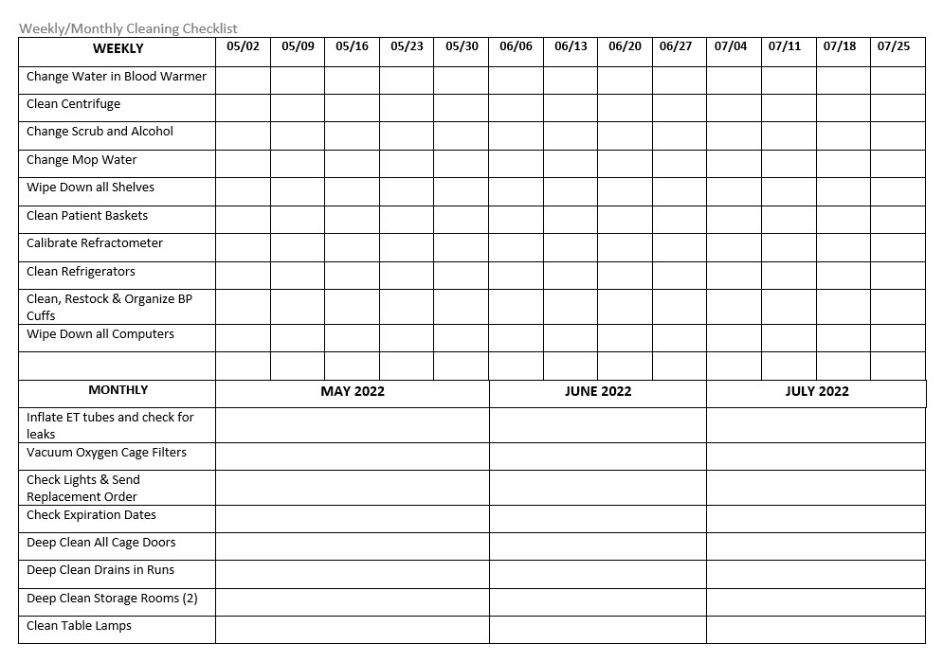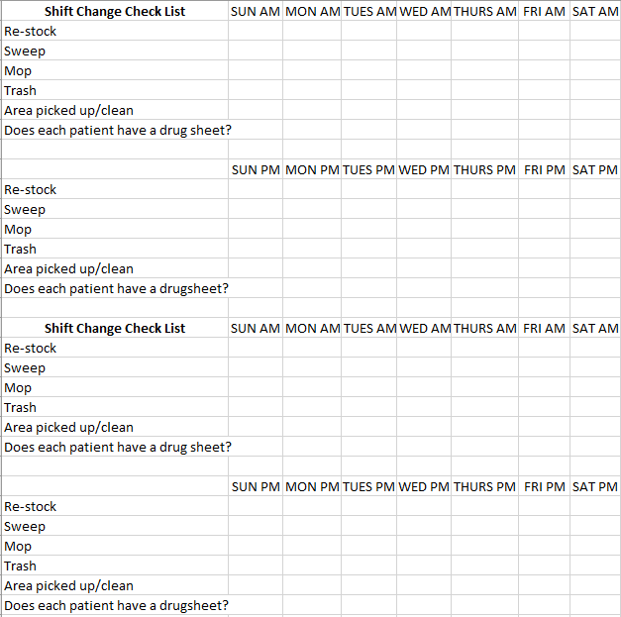

**In the event of a pandemic, additional disinfecting checklist is implemented:**

|  |  |  |  |  |  |  |  |  |  |  |  |  |  |  |
| --- | --- | --- | --- | --- | --- | --- | --- | --- | --- | --- | --- | --- | --- | --- |
| **Disinfect** | **Sunday** | | **Monday** | | **Tuesday** | | **Wednesday** | | **Thursday** | | **Friday** | | **Saturday** | |
|  | am | pm | am | pm | am | pm | am | pm | am | pm | am | pm | am | pm |
| **Purple Binders** |  |  |  |  |  |  |  |  |  |  |  |  |  |  |
| **Drawer Handles** |  |  |  |  |  |  |  |  |  |  |  |  |  |  |
| **Counter Tops** |  |  |  |  |  |  |  |  |  |  |  |  |  |  |
| **Keypad/Mouse** |  |  |  |  |  |  |  |  |  |  |  |  |  |  |
| **Phones** |  |  |  |  |  |  |  |  |  |  |  |  |  |  |
| **Laptops** |  |  |  |  |  |  |  |  |  |  |  |  |  |  |
| **Pumps** |  |  |  |  |  |  |  |  |  |  |  |  |  |  |
| **Chairs** |  |  |  |  |  |  |  |  |  |  |  |  |  |  |
| **Emergency Door Button** |  |  |  |  |  |  |  |  |  |  |  |  |  |  |

|  |  |  |  |  |  |  |  |  |  |  |  |  |  |  |
| --- | --- | --- | --- | --- | --- | --- | --- | --- | --- | --- | --- | --- | --- | --- |
| **Disinfect** | **Sunday** | | **Monday** | | **Tuesday** | | **Wednesday** | | **Thursday** | | **Friday** | | **Saturday** | |
|  | am | pm | am | pm | am | pm | am | pm | am | pm | am | pm | am | pm |
| **Purple Binders** |  |  |  |  |  |  |  |  |  |  |  |  |  |  |
| **Drawer Handles** |  |  |  |  |  |  |  |  |  |  |  |  |  |  |
| **Counter Tops** |  |  |  |  |  |  |  |  |  |  |  |  |  |  |
| **Keypad/Mouse** |  |  |  |  |  |  |  |  |  |  |  |  |  |  |
| **Phones** |  |  |  |  |  |  |  |  |  |  |  |  |  |  |
| **Laptops** |  |  |  |  |  |  |  |  |  |  |  |  |  |  |
| **Pumps** |  |  |  |  |  |  |  |  |  |  |  |  |  |  |
| **Chairs** |  |  |  |  |  |  |  |  |  |  |  |  |  |  |
| **Emergency Door Button** |  |  |  |  |  |  |  |  |  |  |  |  |  |  |

|  |  |  |  |  |  |  |  |  |  |  |  |  |  |  |
| --- | --- | --- | --- | --- | --- | --- | --- | --- | --- | --- | --- | --- | --- | --- |
| **Disinfect** | **Sunday** | | **Monday** | | **Tuesday** | | **Wednesday** | | **Thursday** | | **Friday** | | **Saturday** | |
|  | am | pm | am | pm | am | pm | am | pm | am | pm | am | pm | am | pm |
| **Purple Binders** |  |  |  |  |  |  |  |  |  |  |  |  |  |  |
| **Drawer Handles** |  |  |  |  |  |  |  |  |  |  |  |  |  |  |
| **Counter Tops** |  |  |  |  |  |  |  |  |  |  |  |  |  |  |
| **Keypad/Mouse** |  |  |  |  |  |  |  |  |  |  |  |  |  |  |
| **Phones** |  |  |  |  |  |  |  |  |  |  |  |  |  |  |
| **Laptops** |  |  |  |  |  |  |  |  |  |  |  |  |  |  |
| **Pumps** |  |  |  |  |  |  |  |  |  |  |  |  |  |  |
| **Chairs** |  |  |  |  |  |  |  |  |  |  |  |  |  |  |
| **Emergency Door Button** |  |  |  |  |  |  |  |  |  |  |  |  |  |  |

**General Procedures for Small Animal Isolation**

1. Use your own ID badge to get in – if it does not work there is an emergency card in Cubex (under isolation access badge), but please use your own ID.
2. If the patient has a potentially, zoonotic disease, a warning sign and log must be posted at the entrance to isolation. All individuals entering the Isolation area must sign the log, include the date of care, their phone number and the type of exposure. The log becomes a part of the medical record.
3. Put on gown and booties before crossing line on floor. If appropriate, wear eye and face protection. Goggles are to be used for eye protection.
4. Use disposable diapers/pads for cages, there is some bedding in plastic container. (Towels are provided for cleaning patient up)
5. Put in catheter, start fluids, fill out flow sheet as if patient is in ICU
6. Perform diagnostic tests that are asked for by clinician
7. Tape a cage card with patient information to window, so as to be read from ICU
8. Check for supplies and make list of supplies needed
9. Do Not take any equipment from ICU or other location without consulting Internal Medicine Veterinary Nurse or an Internal Medicine clinician.
10. Put all waste in trash can – use biohazard bag for trash can – do not fill more than ¾ full
11. Put dirty laundry in biohazard bag – leave bag on dirty side of line
12. Do not take any dirty or contaminated objects back over the line
13. Take off booties and gown before crossing line
14. Set up foot bath – use prepared solution in gallon jug
15. Any questions contact Internal Medicine Nurse or Internal Medicine Clinician

### Isolation Cleaning Procedures

STUDENT-Daily

1. Dispose of all waste in trash can – use biohazard bag for trash (when bag is full, close trash bag with red zip tie, do not close tightly and place near the line on the dirty side).
2. Put any dirty laundry in bag and leave near line on the dirty side.
3. Dispose of any sharps or empty medication bottles in the sharps container.
4. Clean all re-usable equipment appropriately - such as clippers - clean off hair, blood, etc.
5. Wipe down counter tops, other items and areas as needed with prepared disinfectant.
6. Mop floor as needed.
7. Change Foot Bath

Conclusion of Case

1. All Daily procedures
2. Clean cage out and wipe down with disinfectant
3. Wipe down all bottles, sharps container, cabinet, and counter tops with prepared disinfectant
4. Leave trash bags and laundry bags near line on the dirty side
5. Remove cage card and sign from ICU window

CARETAKERS – after the patient has been discharged

1. Enter the room using your assigned KSU Vet Med ID Card
2. Spray all the cages down with Rescue terminal solution, let dwell 10 minutes and then rinse with water
3. Squeegee the cages
4. Spray the cart, sink, and exam table and other exposed surfaces with Rescue terminal solution and wipe clean
5. Sweep the floor
6. Mop floor with Rescue terminal solution
7. All Trash and Laundry bags are tied and placed in biohazard bags, labeled and transported to VHC Red Bin north of D-111 outside freezer door. . All biohazard trash is transported to the Diagnostic Lab on Monday, Wednesday, and Friday mornings for autoclaving and disposal or to Red VHC Bin at any time.

## Foot and Mouth Disease Prevention for Visitors Traveling To the United States from Infected Regions of the World

I. Foot and Mouth disease (FMD) is not a human health risk, but humans can carry the virus on their clothing, shoes, body (particularly the throat and nasal passages) and personal items. The disease is extremely contagious and spreads easily among cloven-hoofed animals such as cattle, sheep, pigs, goats and deer. Introduction of FMD into this country would be disastrous to the American livestock industry and wildlife community.

II. Travelers to the United States from FMD-infected (endemic) countries must take steps to help prevent the accidental introduction of this disease into this country. In this protocol, travelers are defined as “VHC Faculty, House Officers, Students, Staff and Visitors”. Any traveler who enters the United States from a known FMD-infected country must not be in the VHC (including pastures, parking lots or vehicles) for five (5) days after entering the United States. If you are planning a trip to a known FMD-infected country, please contact the VHC Hospital Director’s Office prior to departure to discuss this protocol and your return plans. A list of FMD-free countries may be found at <https://www.oie.int/en/animal-health-in-the-world/official-disease-status/fmd/en-fmd-carte/> (Accessed 3/30/2020). If a country is not on this list, it is considered FMD infected.

III. The following preventive measures should be taken by travelers to the United States from FMD- infected countries (taken from The Red Book 11-3-2020):

A. Avoid farms, sale barns, stockyards, animal laboratories, packing houses, zoos, fairs or other animal facilities for *5* days prior to travel to the United States.

B. Before travel to the United States, travelers must launder or dry clean all clothing and outerwear. All dirt and soil should be removed from shoes by thorough cleaning prior to wiping with cloth dampened with a bleach solution.

* 5 teaspoons of household bleach in 1gallon of water).
* Luggage and personal items (including watches, cameras, laptops, CD players and cell phones) should be wiped with a cloth dampened with bleach solution, if soiled.

C. Travelers must avoid contact with livestock or wildlife for 5 days after arrival in the United States. Extra precautionary measures should be taken by people traveling from farms in infected locales to visit or work on farms in the United States. Clean clothing should be worn after the visitor showers and shampoos thoroughly. Visitor’s traveling clothes should be laundered or dry cleaned immediately. Off-site activities should be scheduled for the visitor’s first 5 days in-country and contact with livestock or wildlife should be strictly avoided.

D. Travelers must agree to be physically present in the United State five days prior to their arrival at the Kansas State University Veterinary Health Center

## Primate (Non-Human) Occupational Safety

**Personnel Responsibilities: All persons having direct or indirect contact with nonhuman primates (NHPs) and/or their bodily fluids or wastes should be informed of the risks. Those potentially at risk and in need of education include staff, volunteers, and students in animal care, veterinary, education, and research departments.**

Policy: Due to human health and safety risks associated with providing veterinary care for non-human primates, particularly the Old-world species, it is the policy of the VHC Zoological Medicine Service to discourage seeing privately-owned non-human primate patients. In the event that a non-human primate patient is scheduled for evaluation of a medical condition or is presented for emergency care, the following guidelines will be strictly adhered to:

A. Students are prohibited from working with non-human primate patients without direct clinician supervision AND appropriate PPE must be worn at all times.

B. All clinicians, staff, and students in proximity to the patient are required to wear the following personal protective equipment. The personal protective equipment is to protect YOU from the primate and to protect the primate from you. Moving through the hospital in your PPE with the primate is required because risk of transmission of disease to another patient is very low but risk of transmission of disease to a person in close proximity to the primate is high.

1. Protective wear (disposable clothing) – this includes a disposable gown, and gloves

2. KN95 mask

3. Safety goggles or a face shield and goggles.

4. Latex (or other) gloves. Gloves must be worn when in contact with the patient, patient laundry or items of clothing. If there is a high concern for infectious disease (example Old World primate), double gloving should be performed.

C. When the non-human primate patient is being transported to the VHC and is in the parking lot (privately owned, zoo primate other than Sunset Zoo), the client and the primate should remain outside the VHC contained in the owner’s car or a carrier until the Zoological Medicine Service clinician is present and prepared to proceed with the case.

D. Personnel involvement will be limited to the minimum number of people needed to care for the case to reduce human exposure to the non-human primate.

E. All materials, supplies and instruments used in treating primates must be placed in biohazard bags and taken to Central Prep. Items must be sorted into appropriate biohazard bags (biohazardous materials versus biomedical waste).ALL contaminated biohazardous materials must be cleaned prior to placing in a biohazard bag, secured with an appropriate biohazard zip tie, labeled with “Non-Human Primate”. Please contact staff in Central Supply to collect and transport trash for termination. Do NOT mix bedding, cloth, instruments, tubing, trash, etc. **Do Not fill biohazard bags over 2/3rd full.**

1. Equipment must be cleaned prior to returning it to Central Preparation. Dirt, blood, hair or other debris must be removed. While cleaning, appropriate PPE should also be worn.
2. Instruments must be free of tissue, blood and debris. If not clean, they will be returned to the Exotics service for cleaning. While cleaning, appropriate PPE should also be worn.
3. Items must be separated and placed in separate biohazard bags
   1. Metals
   2. Plastics
   3. Linens
4. Steam Sterilization:

a. Stainless steel instruments

b. Surgical linens, (pan covers, blue towels, pack wraps)

c. Linens must be blood, tissue, and urine free.

d. Do not place wet linens in the biohazard bags. Hang to dry in a designated area before bagging.

1. Low temp sterilization:
2. Clippers and clipper blades
3. ET tubes
4. Non-rebreathing tubing, breathing bags and face masks will be soaked in a chlorhexidine solution (1 ounce (2 tablespoons) of Chlorhexidine Solution per gallon of clean water) or dilute bleach solution (1:10 ratio). Contact Time for chlorhexidine and for dilute bleach - Let stand in solution for 2 minutes, rinse thoroughly, then wipe and hang to air dry in designated area.
5. Patient towels, bulb syringes and suction tubes should be thrown away in biohazard trash.
6. Heavily soiled or known contagious materials must be thrown away in biohazard trash.

**Biomedical Samples**

* 1. NHP biological samples (i.e., urine, blood, semen, feces) should be placed in containers within clearly labeled (i.e., species and identification) leak-proof secondary containers (e.g. sealed plastic container or bag) for transport to the clinical pathology laboratory.  This is necessary to prevent contamination of surfaces during transport and handling.  Persons preparing these samples should wear gloves to prevent contaminating the outside of the container or should wipe the outside of the container with appropriate disinfectant.  Specimens being sent to outside laboratories should have additional labeling to identify them as “nonhuman primate” samples.

**Biomedical Waste**

* 1. Sharp disposable materials (e.g. scalpel blades, needles) must be disposed in a red plastic sharps container. After use, close and take to Mosier B-116 (Ward Services room) and placed on the container.
     1. Do not attempt to recap any needles, rather place them directly in the sharps container. Recapping needles presents a significant human health risk due to potential for needle stick injury and transmission of infectious disease.
     2. Extra caution should be taken when dealing with any sharps in surgery for the same reason.

c. Solid Biohazardous Waste

1. Personal Protection Equipment (PPE) such as protective wear (disposable gowns/clothing), latex (or other) gloves, and face mask (or safety goggles) must be worn by staff when in contact with the patient. Patient laundry or items of clothing that have been in direct contact with the nonhuman primate must be placed in a biohazard bag for disposal.

2. Trash (such as paper towels, used gauzes, cloth like materials, plastics) are to be placed in a separate biohazard bag from the surgical equipment and sharps for disposal.

3. Linens and bedding will be placed in a separate biohazard bag from trash and PPE.

4. Biomedical waste will be disposed of in Mosier J-129 in an available rigid, leak-proof container. Do not place bags on the floor.

**Biohazardous Bags**

a. All items coming into Central Prep contained within biohazard bags must be bagged and closed at the point of use. Do not transport open bags through the hospital. Bags must not be filled more than 2/3 full.

b. Bags must be zip tied with biohazard ties at the point of use. Bags that are folded over and taped will not be accepted by Central Preparation personnel.

c. Individuals who deliver biohazard bags containing materials from non-human primate patients to Central Prep **must** verbally communicate the contaminant delivery to the Central Prep staff.

II. Standard Operating Procedures:

1. Personal Hygiene
   1. Any person that will be entering or working in an area of a NHP should adhere to good general hygiene practices
      1. Eating, drinking, applying cosmetics, or handling contact lenses should NOT be permitted in a NHP area. Any food intended for human consumption should not be kept or opened near a NHP.
      2. Hand-washing should be performed before handling animal food items, after removing gloves, before leaving a primate area, and before eating, drinking, applying cosmetics, handling contact lenses, or smoking after working in a primate area.
      3. Disposable gloves should be changed often and when going from one activity to another (i.e., from cleaning to feeding), and when they become soiled or develop tears or holes.
      4. Work clothing should be changed when visibly soiled or contaminated.
      5. Persons should shower when contamination of skin or hair has occurred.
      6. Nets, protective leather gloves, and other equipment should be cleaned and disinfected following each use.  Since complete disinfection may be difficult, leather gloves should be dedicated for nonhuman primate use.

B. If scratched, bitten, needle skin prick, or feces and/or urine is exposed to the nose, mouth, or eyes:

1. For skin exposure: Immediately begin by flushing and/or scrubbing the affected area with chlorhexidine or betadine scrub and running tap water. Continue this process for **15 minutes**. Do not use chlorhexidine or betadine scrub in the eyes! For a briskly bleeding or other serious wound, go directly to Ascension Via Christi Hospital.

2. For eye or mucous membrane exposure: Immediately irrigate with sterile saline or water for **15 minutes**. Use eye wash station when available.

3. Apply a temporary bandage from the First Aid Kit.

4. Immediately proceed to Ascension Via Christi Hospital for medical evaluation and wound cultures if indicated.

5. Report the accident to your supervisor immediately. Do not let this step delay the seeking of medical care. If you are unable to communicate with your direct supervisor, proceed to an emergency care facility as the immediate first step.

a. Report the ID number of the animal to which you were exposed, the location where the exposure took place, and the type of exposure.

b. If you are unable to contact your supervisor before going to the hospital, report the accident to your supervisor as soon as possible after the medical evaluation.

III. Diseases of Concern:

A. Tuberculosis: Tuberculosis is a serious debilitating disease of primates that is caused by *Mycobacterium tuberculosis*. Old World primates are most susceptible, but tuberculosis also occurs in New World monkeys and great apes. Inhalation and ingestion are the most common routes of transmission. Clinical signs in primates include debilitation, coughing, chronic diarrhea, and draining skin lesions.

1. Cercopithecine Herpes Virus I (B Virus): Herpes B virus can cause a fatal encephalitis in humans. Macaque monkeys and other Old World primates are the natural hosts for this virus, and they usually have no clinical symptoms associated with the infection. When they are shedding the virus, they may have a mucocutaneous ulcer (cold sore) on the lips. The virus is transmitted via bites and scratches, or by mucous membrane contact with infected secretions (including blood, saliva, or urine).
2. ***Simian Immunodeficiency Virus (SIV): This virus, present in some species of Old World monkeys, causes a clinical disease in monkeys that is similar to human AIDS. There is evidence of seroconversion to SIV in humans and the long-term effects are unknown. Avoidance of secretions is strongly recommended.***

## Standard Operating Procedure for Sharps Container Removal and Restocking in the Veterinary Health Center

Expectations:

As always patient care and ancillary care come first in the performance of duties within all areas of the VHC. However, this leaves ample time to carry out the functions of removing full sharps containers to new storage area (G-112D/SW 105) and the restocking of new sharps containers stored in (H-112) on a daily basis. The removal and restocking will be aided by a cart which is stored in (G112D/SW 105) and trash bags may be employed to keep full and clean containers separated. When the cart becomes soiled it can be sanitized using the water outlets on I-70 the area between the Small and Large Animal areas with the proper cleaning agents. On the daily route the sites in the Small Animal Hospital will be serviced first according to the various needs of each separate area followed by the sites in the Large Animal Hospital. To prevent cross contamination the person in charge of these duties will clock out at the end of the day in the Large Animal side of VHC and not reenter the Small Animal Side that day. This means that ample time should be allotted for these duties in the afternoon at least in the Large Animal aspect. However this is not an excuse to not have all animal care and ancillary duties completed before performing these tasks. Also any pages received will be immediately responded to and if circumstances call for reentry into the Small Animal Hospital Shoe Covers and Gloves will be worn to prevent cross contamination. Again this is not an excuse to not respond to pages issued in the Small Animal section of VHC. Failure to complete these removal and restocking procedures on a daily basis will merit discipline in line with that of failing to complete animal care and ancillary duties on a daily basis. Instructions for servicing the various areas of the VHC will be broken down by the requests submitted by staff and clinicians.

Keys:

There are several keys that allow access to the full sharps storage room (G-112D/SW 105), one is retained by individual performing these tasks, one is retained by Oncology, and two will be placed in the Cubex units. Procurement Officers (Rob Reeves 785-532-4173 or Devin Clark 785-532-2990) and Small Animal Technicians also have sub master keys that allow access. Keys that open the empty sharps room (H-112) are retained by Dispensary and also Procurement Officers have keys that open the room.

Disposal:

Public Safety has an established schedule for picking up sharps containers, chemo waste, and certain hazardous materials. If you notice that (G-112D/SW 105) is filling up and not being picked up please contact Procurement Officers and they will make arrangements to have the room cleared. If Procurement Officers are unavailable fill out a Sharps and Medical Waste Request Form for Public Safety to schedule a pick-up which is available on the KSU Environmental Safety and Health website.

***Small Animal Hospital:***

**Dispensary (A-119)**

Dispensary will need a daily check with staff to see if they have full sharps containers and what they need for both empty sharps containers and empty chemotherapy containers for restocking. Any chemo waste generated by the Dispensary will be picked up on a daily basis. They also have an available key to open (H-112) where the empty clean containers are stored.

**Community Practice Learning Center-Pet Health (A-103)**

Community Practice will need to be serviced in the following areas:

Treatment Area 4 sharps containers. One located on each end of treatment tables. Four total kick buckets located beneath each treatment table.

There are also sharps containers in the following rooms (A-103A, A-103B, A-103E Surgery, A-103G, A-103H, A-103J)

Old Community Practice Learning Center-Pet Health (, B-103, B-122, B-123, B-124, B-126, B-133) There is a single container on top of the cabinetry in each of these rooms that need to be checked daily for replacement.

**Oncology (B-106, B-107)**

Oncology will need a daily check on their sharps container and an empty when required. They will take out and replace their own chemotherapy containers and the biohazard trash will be removed by Small Animal Technician when they clean this ward. Oncology also retains a key to the full sharps room (G-112D).

**Cardiology (B-101, B-102)**

**Endoscopy (B-112)**

**Dental (B-113)**

**Bandage Room (B-117)**

**Wards and Ancillary Rooms (B-146, B-147, B-148, E-114, E-116, E-117)**

**ICU (B-149)**

**Small Animal Surgery and Ancillary Rooms (C-111, C-112, C-113, C-114, C-116, C-117, C-122, C-123, C-124, C-126, C-127)**

**Ophthalmology (E-101, E-102, E-103, E-108)**

**Dermatology (E-104)**

**Self Help Lab (E-113)**

**Junior Surgery Lab (O-258, O-259, O-261, O-262, O-263)**

All of the above listed services and areas from Cardiology to Junior Surgery Lab will drop off their full sharps containers in Ward Services (B-116) and replenish their own from the supply kept in this room. It is extremely important that the full containers are removed from this room daily and an adequate stock of empty containers be kept on hand.

**Central Prep (C-103, C-104, C-107)**

On a daily basis ask Central Prep personnel if they have full sharps containers and replenish their stock with empty containers. This will keep you from cross contaminating their areas by traveling through them.

**Radiology (F-113, F-122, F-126, F-128)**

On a daily basis check the containers in each of these rooms and replenish as needed.

***Large Animal Hospital:***

**Equine (H-116)**

This room will serve as a centralized pickup for the Equine Section. In the black metal cabinet there is a stock of 5-6 small empty containers which needs to be maintained. Full sharps containers are located under the countertop on the east wall. This area must be serviced daily.

**Livestock Services (J-113)**

This room will serve as a centralized pickup for the Ag Practice section. There are5-6 small containers and one large empty container in a cabinet behind the door of this room as stock which must be maintained. Full sharps containers are set on the floor behind the door. This area must be serviced daily.

**Isolation (J-191)**

This area will serve as a centralized pickup for the outer Isolation Units. Full containers will be located beside the (J-191) door in Tier 3. No stocking needed, but full containers should be removed daily.

**Large Animal Surgery (G-109)**

A stock of four large containers will be maintained in this room. The Veterinary Nurse, Veterinary Assistant will take full containers to the drop site in (J-113), but the stock of four large empty containers is to be monitored daily.

## Rabies Vaccination Post-Exposure Protocol

* If the animal doing the biting is an owned animal, and is known to be current on its rabies vaccine, then the bitten animal does not need a rabies booster due to that exposure.
* If the animal is bitten by a stray or wild animal that is submitted for rabies testing, the bitten animal can be boostered when seen or can wait until the test results are known.
* Please note that an animal is not considered current on its rabies vaccine until 28 days after receiving its first rabies vaccine.
* Animals are considered to be overdue the day after their current vaccine duration expires.

**2016 Rabies Compendium Guidelines**

Post exposure management for any animal exposed to a confirmed or suspected rabid animal

1. **Dogs, cats, and ferrets that are current on rabies vaccination** 
   1. Immediately receive veterinary medical care for assessment and wound cleansing
   2. Booster rabies vaccination within 96 hours
   3. The animal should be kept under the owner’s control and observed for 45 days
2. **Dogs, cats, and ferrets that have never been vaccinated**
   1. Euthanized immediately OR
   2. Placed in strict quarantine for 4 (dogs and cats) or 6 (ferrets) months
      1. Strict quarantine in this context refers to confinement in an enclosure that precludes direct contact with people and other animals.
   3. A rabies vaccine should be administered at the time of entry into quarantine to bring the animal up to current rabies vaccination status.
      1. It is recommended that the period from exposure to vaccination not exceed 96 hours
      2. If vaccination is delayed, public health officials may consider increasing the quarantine period for dog and cats from 4 to 6 months, taking into consideration factors such as the severity of exposure, the length of delay in vaccination, current health status, and local rabies epidemiology.
3. **Dogs and cats that are overdue for a booster vaccination and have appropriate documentation of having received a USDA-licensed rabies vaccine at least once previously**
   1. Treatment is the same as #1 above
   2. If booster vaccination is delayed, public health officials may consider increasing the observation period for the animal, taking into consideration factors such as the severity of exposure, the length of delay in booster vaccination, current health status, and local rabies epidemiology.
4. **Dogs and cats that are overdue for a booster vaccination and without appropriate documentation of having received a USDA-licensed rabies vaccine at least once prior to the incident.**
   1. Immediately receive veterinary medical care for assessment, wound cleansing, and consultation with local public health authorities.
   2. The animal can be treated as unvaccinated, immediately given a booster vaccination, and placed in strict quarantine.
      1. See #2 above
   3. Alternatively, prior to booster vaccination, the attending veterinarian may request guidance from the local public health authorities in the possible use of prospective serologic monitoring. Such monitoring would entail collecting paired blood samples to document prior vaccination by providing evidence of an anamnestic response to booster vaccination
      1. If an adequate anamnestic response is documented, the animal can be considered to be overdue for booster vaccination and observed for 45 days.
         1. See #3 above
      2. If there is inadequate evidence of an anamnestic response, the animal is considered to have never been vaccinated and should be placed in strict quarantine.
         1. See #2 above
5. **Ferrets that are overdue for a booster vaccination** 
   1. Should be evaluated on a case-by-case basis, taking into consideration the below listed factors to determine the need for euthanasia or immediate booster vaccination followed by observation or strict quarantine.
      1. Severity of exposure
      2. Time elapsed since last vaccination
      3. Number of previous vaccinations
      4. Current health status
      5. Local rabies epidemiology

**How to enter charge/document the rabies vaccine and create a rabies vaccination certificate**

1. Choose the appropriate rabies vaccine and get a rabies tag (both will be in Cubex)
   1. Choose Purevax rabies for cats
      1. Give SQ low on the right hind leg
   2. Choose Imrab 3 for dogs
      1. Give SQ in the right shoulder
2. Place rabies sticker from the vial on the vaccination line in the medical record
   1. Write the tag number below the sticker
   2. Write 1 year under the sticker
3. You will need to enter the charge for the rabies vaccine into Vetstar under the service the patient was registered as it will not update the charge when the vaccine is obtained from Cubex.
   1. V1090 for cats
   2. V1126 for dogs
4. When you go to exit the charge, the system will populate the rabies certificate. You will need to enter in the following information in this order:
   1. The first line will automatically state the name of the chosen vaccine
   2. Enter rabies tag number
   3. It will automatically have the manufacturer (Merial) listed on the next line, so enter through it.
   4. Enter the serial number of the vaccine (this is on the sticker)
   5. Expiration years (this is the duration of the vaccine)
      1. Enter the number “1” for this section as all the vaccines will be considered good for 1 year for simplicity.
   6. Vaccine expiration (also the duration of the vaccine)
      1. This will automatically populate for a year from the vaccine date. Do not change.
   7. Lot number
      1. It will not accept a number. Enter on through it.
   8. Drug expiration date (this is the shelf life of the vaccine)
      1. Enter as mmddyy. You do not need to enter the back slashes, but it will also take it if you do. This date is on the sticker.
   9. Hit enter and it should bring up the option to print the certificate. If you go through it too quickly and miss the printing option, you can reprint a certificate by entering these codes in the command line:
      1. rbc1 (dogs)
      2. rbrc (cats)
   10. **Sign the certificate** 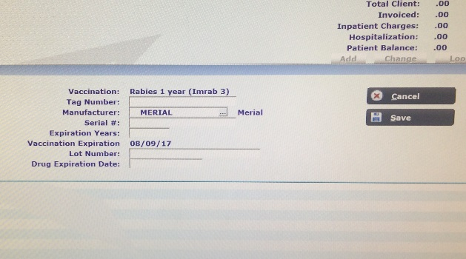
5. If an owner refuses to have a booster given for whatever reason, document this in the discharge instructions. Also include a clause stating the animal should have a rabies booster within 96 hours of the incident.

# Appendix A

Calf Isolation Procedures

1. Do not house patients from different owners/dairies side by side unless absolutely necessary.
2. Use all appropriate footbaths.
3. Disposable barrier gowns and gloves are required to enter a stall with a patient at the discretion of the senior clinician.
4. Use separate thermometers and stethoscopes for each patient.
5. Keep contaminated items with the patient from which they come.
6. Thermometer, stethoscope, barrier gowns, etc. should be kept next to that patient's stall to avoid cross-contamination.
7. Please label milk bottles with client name and case number to keep them separate. Store milk bottles in the refrigerator with an examination glove over the nipple; do not leave milk at room temperature for more than 2 hours.
8. Items taken into Calf Isolation from the main Large Animal Hospital, Central Supply, etc. should remain there until the calf goes home; all equipment should be properly cleaned and disinfected.
9. Do not reach for anything clean (syringe boxes, cupboards, etc.) with dirty hands or gloves. Try to have everything ready prior to a procedure; or remove dirty gloves, get items needed and put on a new pair of gloves.
10. Used milk bottles must be washed with soap, rinsed, soaked in dilute bleach (2oz. per gallon of water) for at least 20 minutes, and then rinsed well.
11. Wash hands before, after, and between animals to avoid spreading contamination!

# Appendix B

## EPA Registered Disinfectants used in the VHC

|  |  |
| --- | --- |
| VHC Disinfectants | EPA Registration Number |
| Rescue Spray | 46781-6 |
| Rescue Wipes XL | 46781-8 |
| Rescue/Intervention Concentrate | 74559-4 |
| Formula 409 All Purpose Cleaner | 5813-73 |
| Signet Neutral Disinfectant DS1(Virex II | 10326-141-70627 |
| Q.T.3 Disinfectant | 6836-349 |
| CVM Facilities Floor Disinfectant | EPA Registration Number |
| Virex II 256 One-Step Disinfectant Cleaner and Deodorant: Quat Based Disinfectant | 70627-24 |

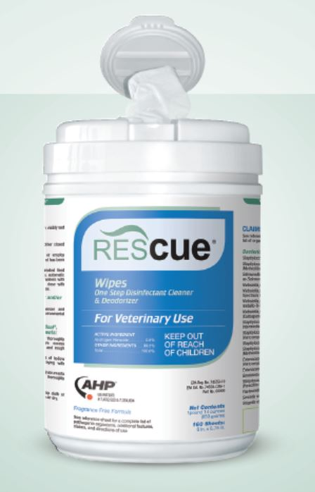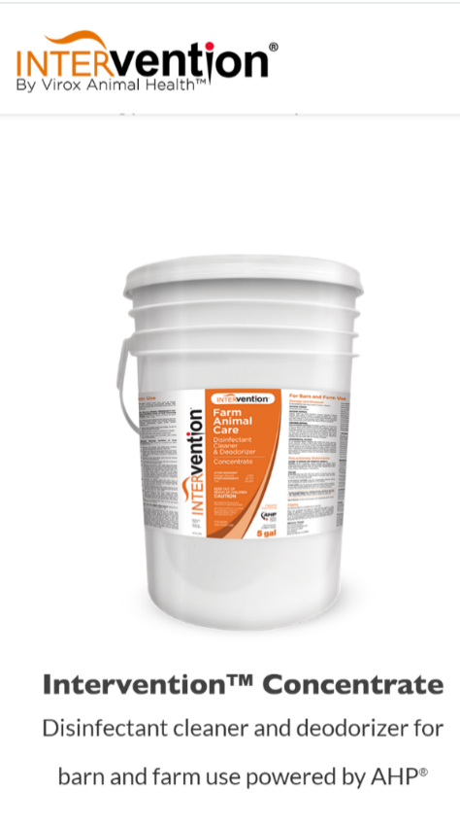

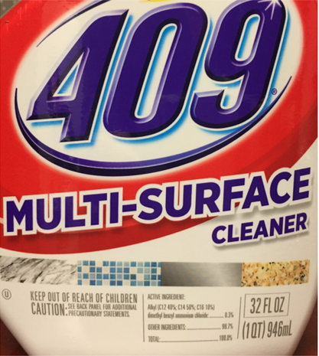 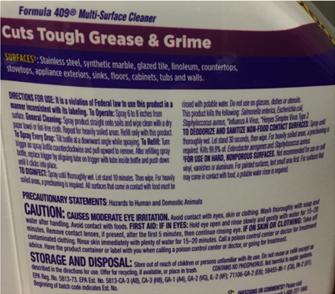

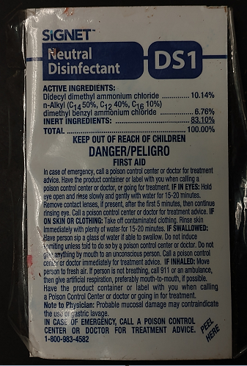 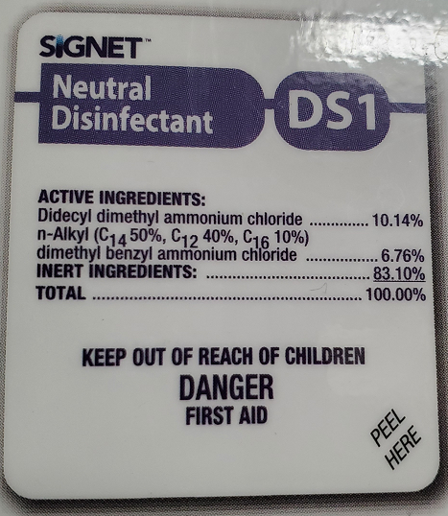

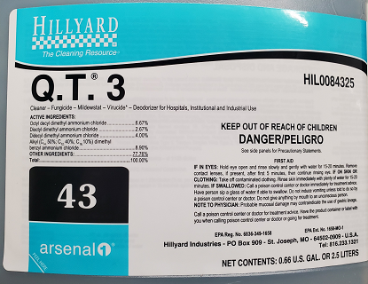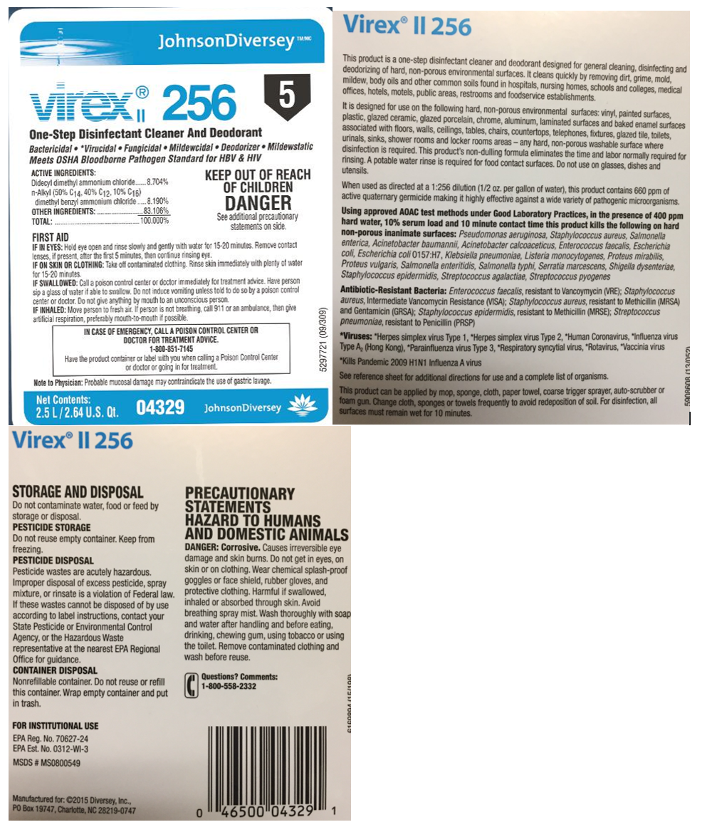

|  |  |  |  |
| --- | --- | --- | --- |
| **Disinfectant** | **Volume of Concentrated Disinfectant to Prepare 1 Gallon of Final Product** | **Label** | **Expires** |
| Rescue/Intervention – Mop Bucket | 1 ounce | Rescue/Intervention 1:28 | 1 Month |
| Rescue/Intervention – Spray Bottle | 2 ounces | Rescue/Intervention 1:64 | 1 Month |
| Bleach 1:10 | 13 ounces | Bleach Solution 1:10 | 24 Hours |
| Bleach 1:100 | 1.3 ounces | Bleach Solution 1:100 | 24 Hours |

Disinfectant Standard Dilution Chart

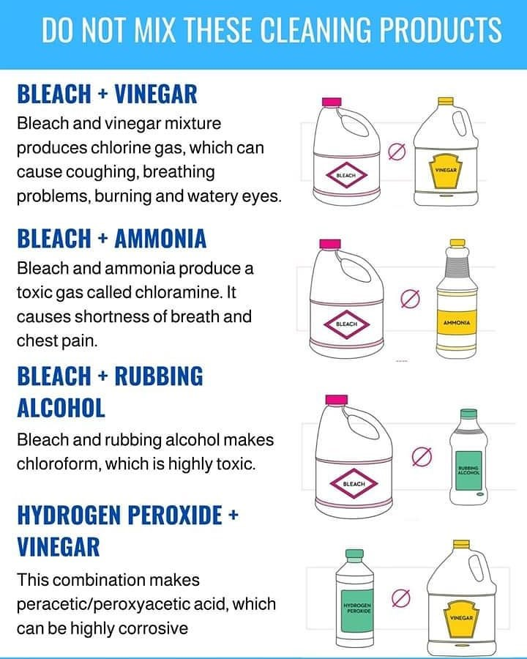

Wall Charts

## Antimicrobial Spectrum of Disinfectants

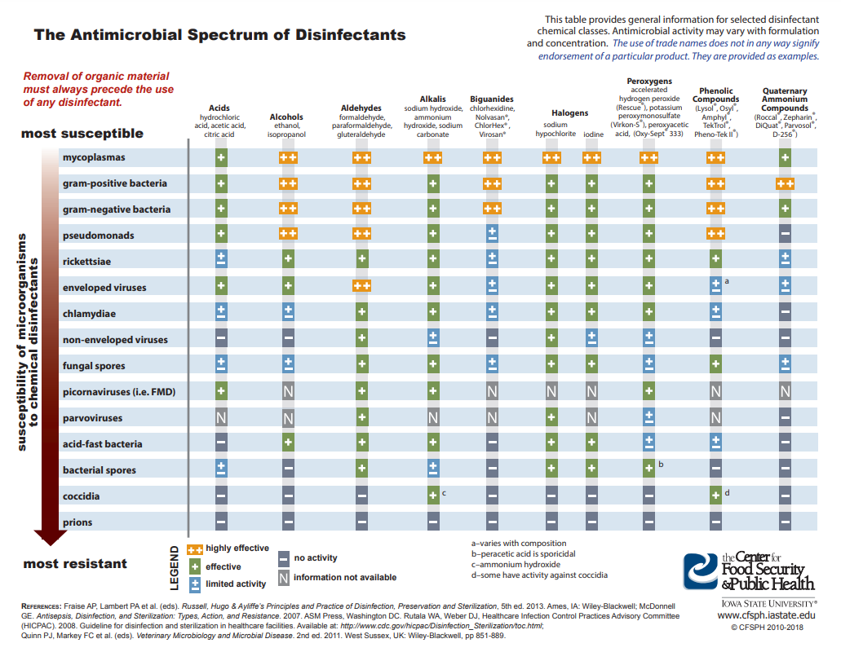

**ICU Disease Protocol Quick Reference**

1. **Parvovirus**

Location: Isolation (no exceptions)

PPE: Consistent with Isolation Protocol

Biohazard: Consistent with Isolation Protocol

1. **Distemper**

Location: Confirmed Distemper cases will be placed in Isolation. If other patients are in isolation, then these cases should be isolated in ICU the best way possible.

PPE: Wear gloves, wash hands OR consistent with isolation protocol if in isolation

Biohazard: No, OR consistent with isolation protocol if in isolation

1. **Leptospirosis**

Location: ICU bottom cages. Walk patients in area designated for leptospirosis patients. Clean any urine by spraying with disinfectant first and then wiping with paper towels. (Low risk zoonotic disease)

PPE: Wear gloves, wash hands

Biohazard: Yes

1. **Salmonella**

Location: ICU bottom cages

PPE: Wear gloves, wash hands

Biohazard: Yes

1. **Tularemia**

Location: Normal ICU protocol

PPE: Wear gloves, wash hands

Biohazard: No

1. **Histoplasmosis**

Location: Normal ICU protocol  
PPE: Wear gloves, wash hands

Biohazard: No

1. **Aspergillosis**

Location: Normal ICU protocol

PPE: Wear gloves, wash hands

Biohazard: No

1. **Kennel Cough (dog)**

Location: Try to avoid hospitalization of these patients. Otherwise, Isolation. If other patients are in isolation, the cat ward may be used. Try to avoid housing other patients in the cat ward.

PPE: Consistent with isolation protocol OR

Biohazard: Consistent with isolation protocol OR

1. **Methicillin-resistant Staphylococcus pseudintermedius**

Location: ICU

PPE: Wear gloves, wash hands

Biohazard: Yes

1. **Multi-drug resistant E. Coli**

Location: ICU

PPE: Wear gloves, wash hands

Biohazard: Yes

1. **Streptococcus canis (necrotizing fasciitis)**

Location: ICU (this is low-risk zoonosis)

PPE: Wear gloves, wash hands

Biohazard: Yes

1. **Feline Upper Respiratory Disease Complex (Calicivirus)**

Location: Isolation

PPE: Consistent with isolation protocol

Biohazard: Consistent with isolation protocol

1. **Canine Influenza**

Location: Isolation

PPE: Consistent with isolation protocol

Biohazard: Consistent with isolation protocol

**Infected cats who cannot be admitted to isolation due to disease transmission to other cats already housed in isolation may be housed in the dog ward. Similarly, infected dogs who cannot be admitted to isolation due to disease transmission to other dogs already housed in isolation may be housed in the cat ward. Try to avoid housing other animals in these wards, if possible. ICU staff may care for these patients in the ward and do hourly treatments.**

## Select Zoonotic Diseases of Companion Animals

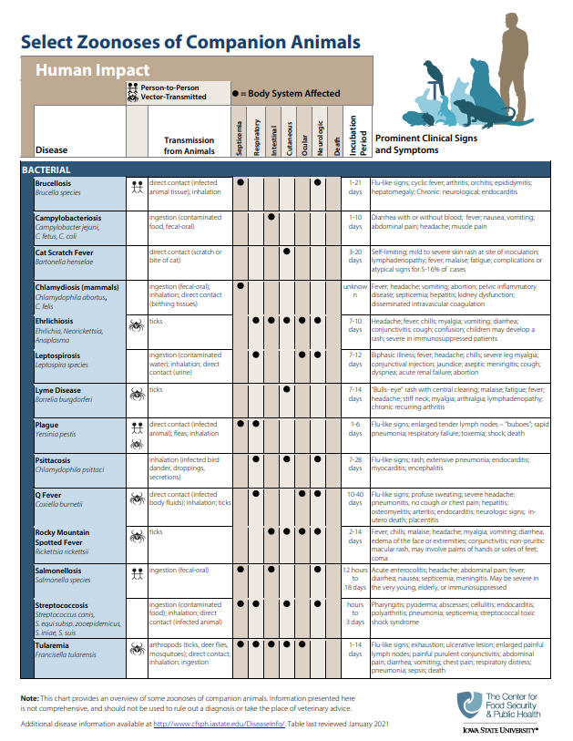

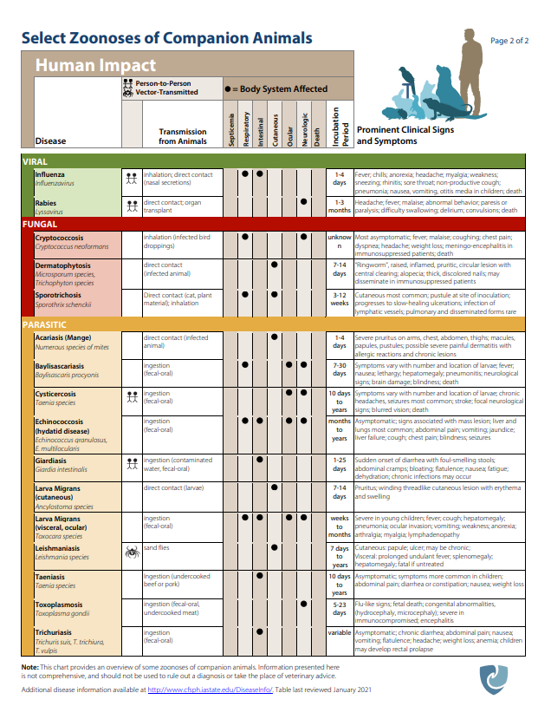

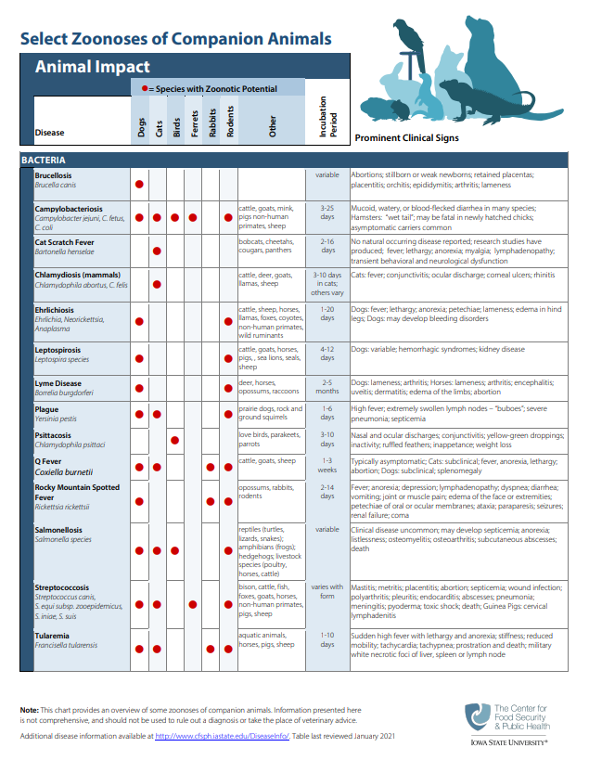

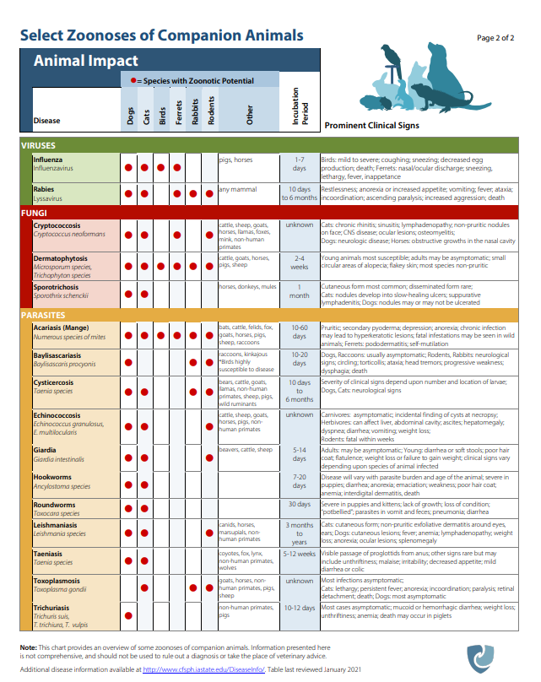

## Zoonotic Disease Fact Sheet

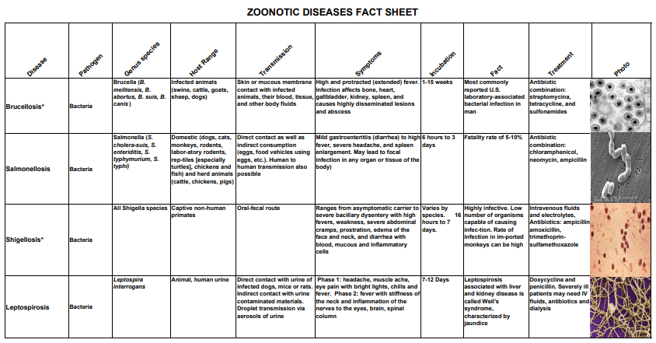

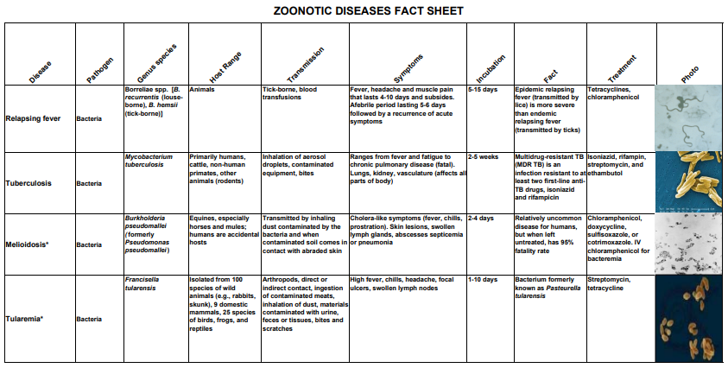

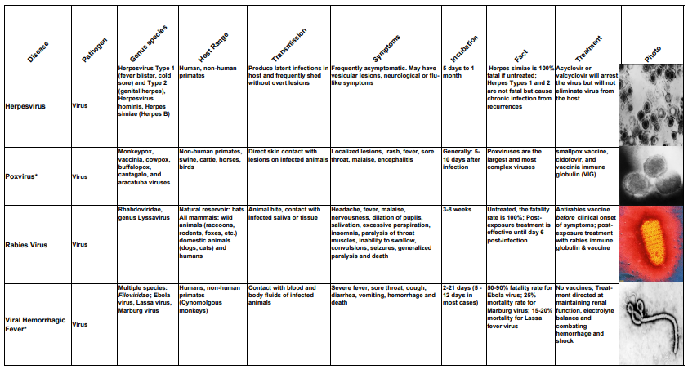

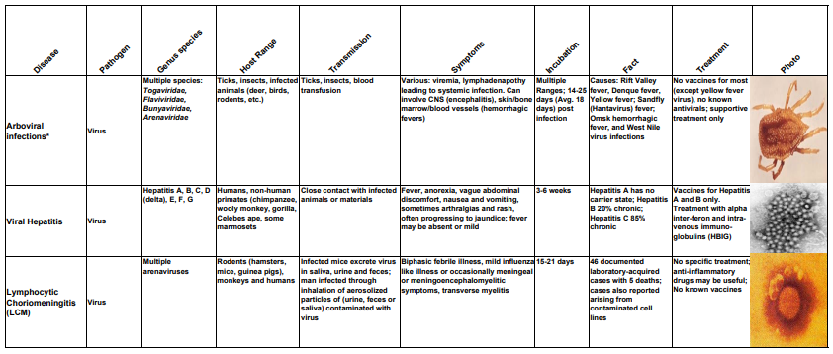

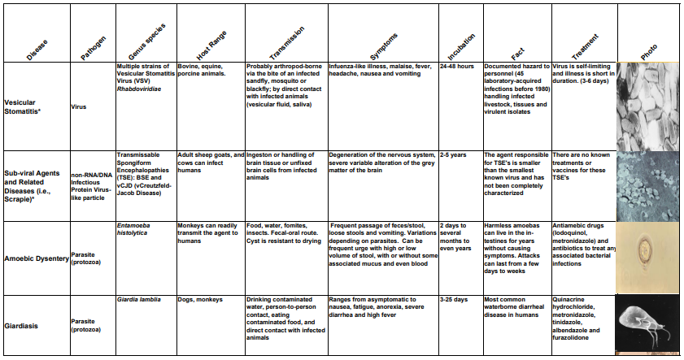

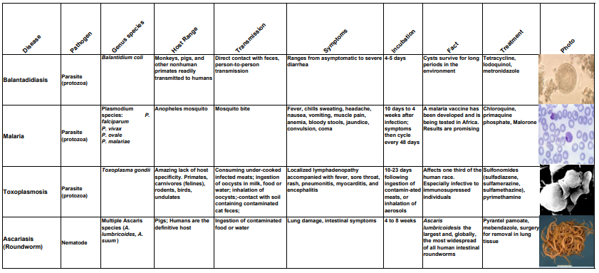

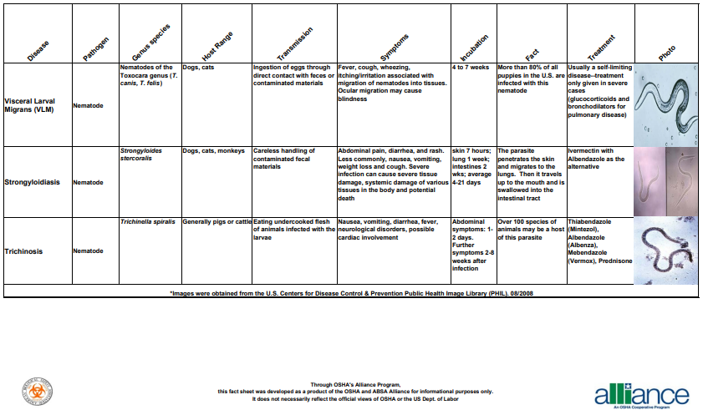

**Annual RPP Enrollment Diagram**

[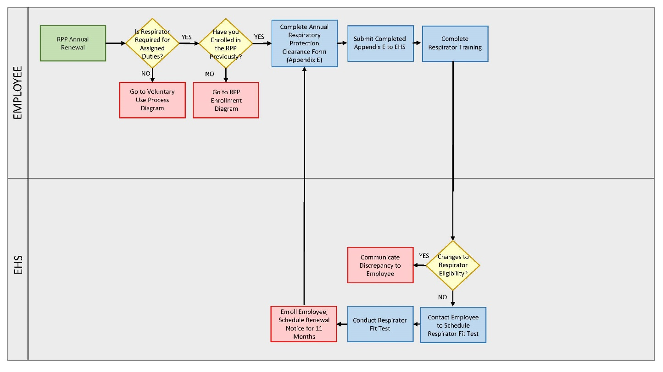](https://www.k-state.edu/safety/occupational/respiratory-protection/Annual-RPP.pdf)

**Initial RPP Enrollment Diagram**

[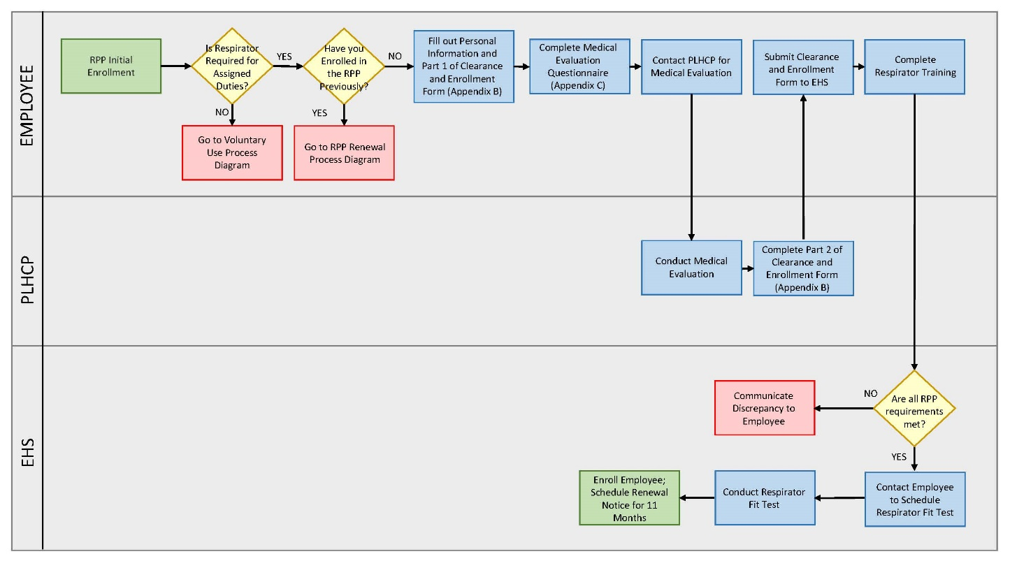](https://www.k-state.edu/safety/occupational/respiratory-protection/Initial-RPP.pdf)

**Voluntary Use RPP Enrollment Diagram**

[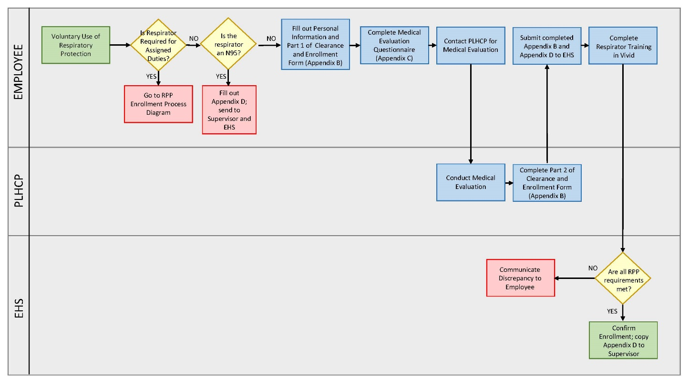](https://www.k-state.edu/safety/occupational/respiratory-protection/Voluntary-RPP.pdf)