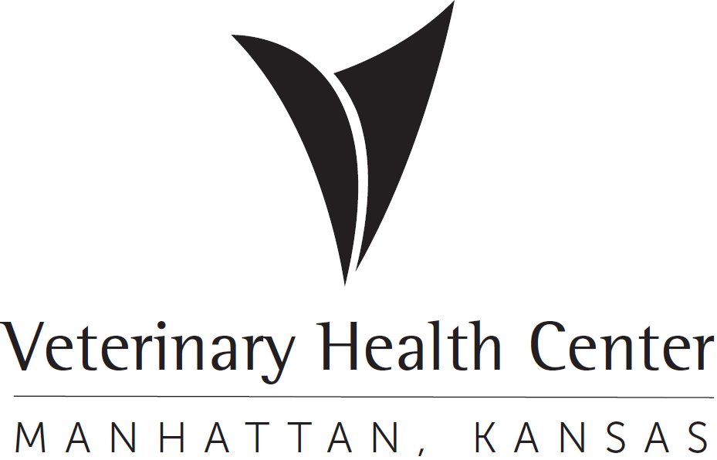 | OFFICIAL PROTOCOL

ALPACA TEACHING HERD CHARGE PROCEDURES

Purpose: To ensure appropriate documentation and charging for DCS Alpaca herd.

- A medical record is not required provided:
  - The alpaca is covered under an Institutional Animal Care and Use Committee (IACUC) protocol for research and/or teaching,
  - The alpaca is not being treated, and
  - The alpaca will not spend the night in the VHC.
- Alpacas receiving treatment:
  - Department of Clinical Sciences (DCS) owned teaching alpaca that are being treated must be registered and have a medical record.
  - DCS owned teaching alpaca that stay overnight must be registered, have a medical record and be in-patiented.
  - Record fees, equipment fees, operating room fees, lab fees, supplies, drugs, anesthesia, procedure fees, professional fees, etc. must be entered in Vetstar for the patient being treated and/or staying overnight. Each DCS owned teaching alpaca will have the DCS Teaching/Research Animal (Z2190) applied to that animal’s VetStar record (only needs entered once). This code will automatically discount all appropriate charges when that animal is ever brought in for treatment. The discounts are as follows: 100% of the record fee, professional fees and 50% of the daily care charges to the KSU/CS alpaca teaching herd account # 139835.

