 | OFFICIAL PROTOCOL

Human Post-Bite Protocol

Purpose: To provide direction of what to do when a VHC member is bitten by a patient at the Veterinary Health Center.

Important Initial Steps

- If deemed a life-threatening situation, call 911 for emergency response of medical team.
- Wash bite wound immediately and thoroughly with soap and water. Flushing with povidone iodine is also recommend if available.
- Employees, including student workers who were being paid by the VHC at the time the bite occurred, should follow the process for reporting an employee work-related accident by completion of an incident report. (see attachment)
- CVM students need to notify Clinical Science Office that the accident occurred. There is a student accident report that needs to be completed for all accidents. Students should seek medical care as appropriate and follow their personal medical insurance process for medical care costs.
- If the bite occurs after regular working hours, an email should be sent to Drs. Davis and Duvendack with “Bite occurred in VHC” listed in the subject line.
- Individuals who were bitten should consider seeking medical attention ASAP, even if low risk of rabies transmission, as a tetanus booster and/or antibiotics are commonly indicated at the time of animal bite wounds.
Responsibilities of Veterinarian following Bite
- The primary clinician that was on service for the patient needs to call Riley County Police Dept. (RCPD) dispatch (785-537-2112) to have an animal control officer (ACO) come to collect information for a formal animal bite report.
  - The clinician needs to ask to speak with a dispatcher so they can contact the ACO and advise them they are needed at the VHC because of an animal (provide species) bite wound.
  - Both persons bitten and the owner of the animal will be required to answer questions for the ACO.
  - The ACO will determine necessary steps for 10-day observation period. It is important to request the VHC be notified of arrangements for observation period. This information will include whether the animal can be released from the VHC, the animal should not be discharged from the VHC until the ACO has provided this information to the senior clinician.
  - If the animal is not owned, the ACO will direct appropriate animal care. This information will include whether the animal should be euthanized and tested for rabies.
- Animals should NOT be vaccinated during the observation period.
- If the animal should become unavailable for observation, it should be treated as a rabid animal and consultation with the KDHE (785.296.1500) is recommended. Note that the likelihood of rabies transmission from an animal current on its rabies vaccine is uncommon.
- Follow the established VHC Rabies protocol if patient is symptomatic. Signs of rabies include: Fearfulness, aggression, excessive drooling, difficulty swallowing, staggering, paralysis, seizures, uncharacteristically affectionate, self-mutilation, or increased sensitivity to light.
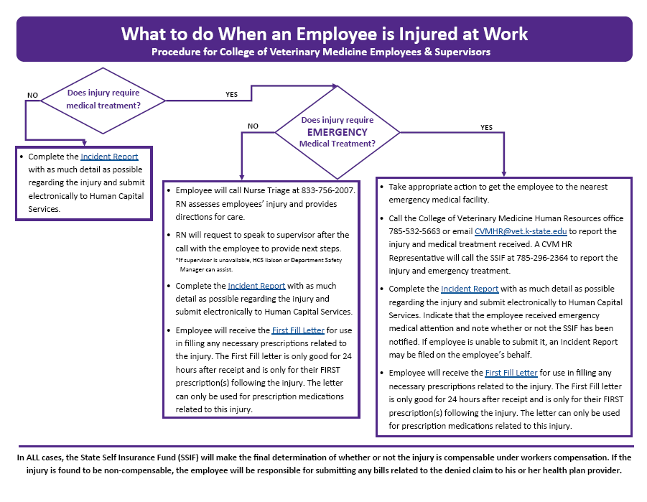
- All warm-blooded animals can be infected with rabies. Birds and reptiles do not transmit rabies.

